A Session on Enhancing Student Understanding of Research and Publications

Date: September 3rd, 2024.
Venue:Seminar Hall, Sachdeva College of Pharmacy

Organized by:Pharmacology Department, Sachdeva College of Pharmacy

Speaker:Ms. Prachi Sharma

Introduction:
On September 3rd, Sachdeva College of Pharmacy organized an insightful session aimed at enhancing the understanding of research and publications among PG students. The session was led by Ms. Prachi Sharma, who shared her extensive knowledge and experience in the field.

Objective:
The primary objective of this session was to provide students with a comprehensive understanding of the research process, the significance of publications in academic and professional growth, and to familiarize them with the tools and techniques required for effective literature searches, data analysis, and scientific writing.

Key Highlights of the Session:
- Introduction to Research and Publications:
Ms. Prachi Sharma began the session by introducing the fundamental concepts of research and the importance of publications in academia. She emphasized how research contributes to the advancement of knowledge and the crucial role publications play in disseminating new findings.

- Platforms for Literature Searches:
The session provided valuable insights into various platforms available for conducting literature searches. Ms. Sharma guided the students on how to efficiently use these platforms to gather relevant information for their research projects.

- Understanding Reviews and Research Papers:
A significant portion of the session was dedicated to explaining the differences between review articles and research papers. Ms. Sharma discussed the structure, purpose, and writing style of both types of documents, helping students to distinguish between them and understand the appropriate contexts for their use.

- Collation and Analysis of Data:
Ms. Sharma also covered the crucial aspects of data collation and analysis. She explained how to systematically collect and interpret data to draw meaningful conclusions, which is essential for producing high-quality research papers.

- Scientific Writing:
The session concluded with a detailed discussion on scientific writing. Ms. Sharma provided practical tips and guidelines on how to write clear, concise, and impactful research papers, ensuring that the students left with a solid understanding of how to communicate their research findings effectively.

Conclusion:
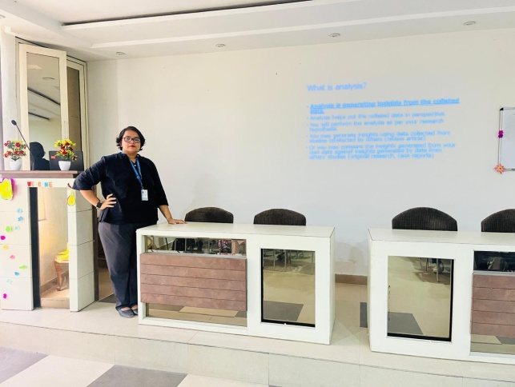
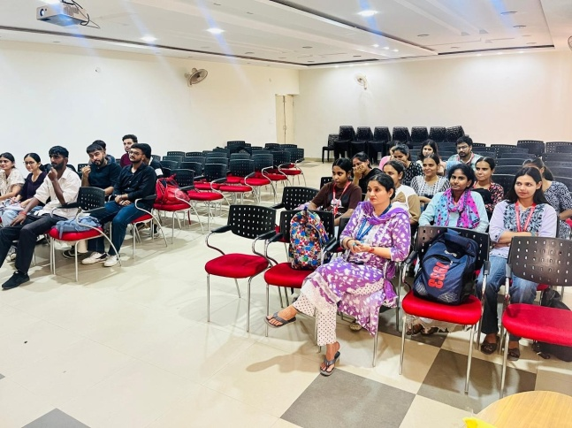
The session was highly beneficial for the students, equipping them with the knowledge and skills necessary to navigate the complex world of research and publications. The interactive nature of the session allowed students to ask questions and gain clarity on various topics, making it a valuable learning experience. Sachdeva College of Pharmacy remains committed to organizing such sessions to support the academic and professional growth of its students.

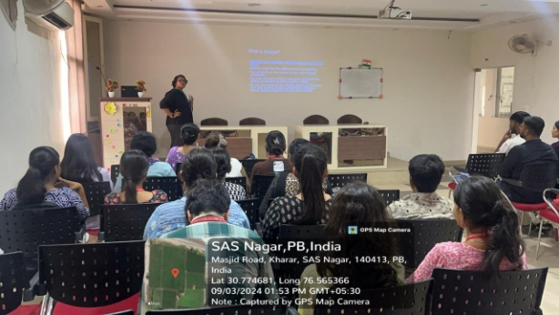
"Interactive moments from the informative session at Sachdeva College Pharmacy.”

