SPORTS PARTICIPATION REPORT

IKG PTU Inter-College Sports Tournament held on 10/02/2026 (2025–2026) (South Zone)
Venue: Baba Banda Singh Bahadur Engineering College, Shri Fatehgarh Sahib
Participating Institution: Sachdeva College of Pharmacy, Gharuan (Mohali)
Introduction
This report outlines the participation and performance of the cricket team of Sachdeva College of Pharmacy, Gharuan (Mohali), in the IKG PTU Inter-College Sports Tournament 2025–2026 (South Zone), hosted at Baba Banda Singh Bahadur Engineering College, Fatehgarh Sahib.
Team Participation and Discipline
A total of 14 students represented our college in the tournament. The team demonstrated exemplary discipline and punctuality by reporting and completing entry formalities well before 9:00 AM, strictly adhering to the tournament schedule.
Upon arrival, the team carefully observed and assessed the ground conditions and pitch to plan their strategy effectively. All required documentation was completed in a timely manner. The following formalities were fulfilled:
- Entry fee submission of ₹ 400
- Cricket ball fee submission of ₹ 1700
- Collection of official fee receipts
The team ensured that all administrative procedures were completed professionally and responsibly before the commencement of the match.
Match Summary
After completing the formalities, the team extended a warm sporting welcome to the host team of Baba Banda Singh Bahadur Engineering College.
Toss & Innings: Sachdeva College of Pharmacy batted first
First Innings Performance:
Our players displayed commendable confidence, teamwork, and determination, scoring 104 runs in 18 overs.The batting lineup showed resilience and maintained a competitive run rate throughout the innings.
FEE RECEIPTS
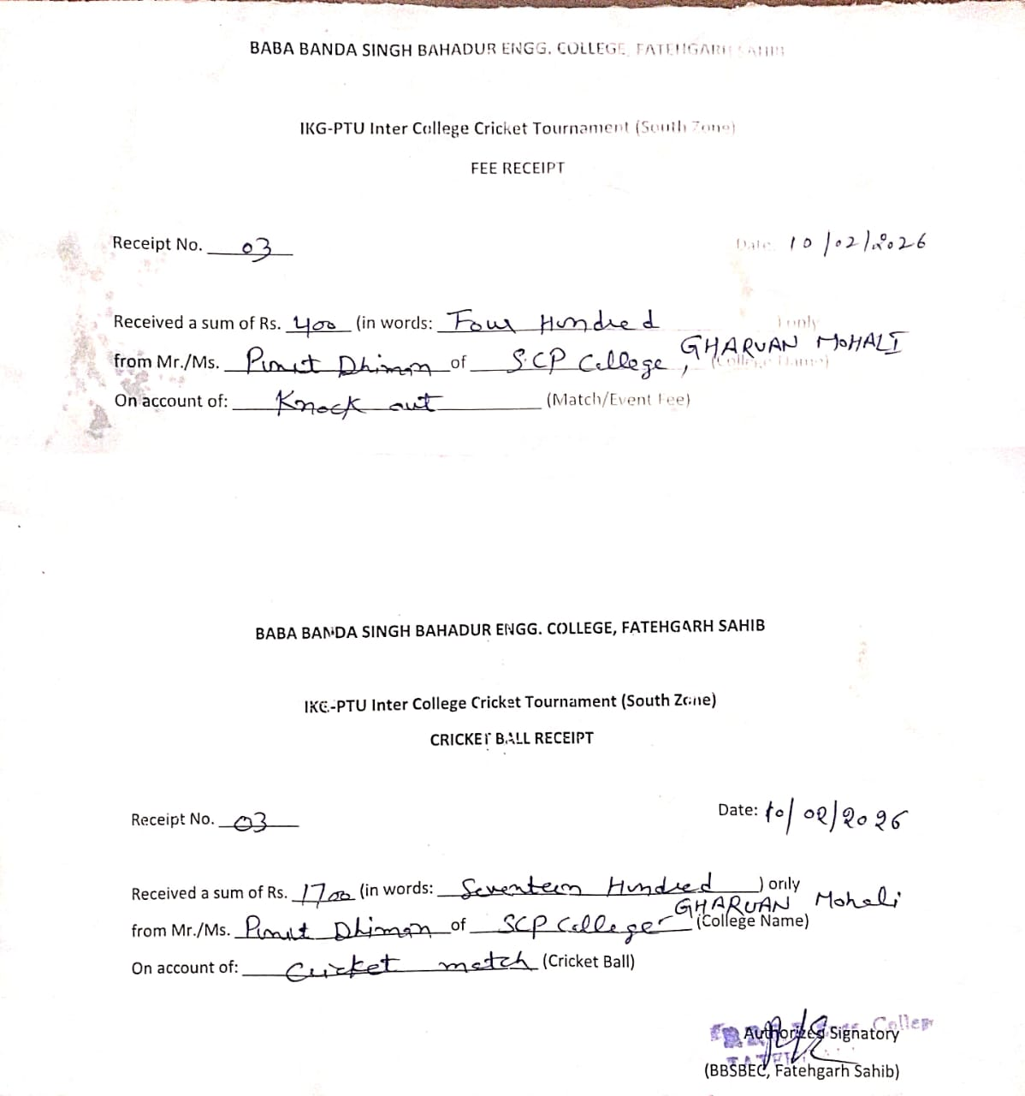
Reporting and Entry of Team
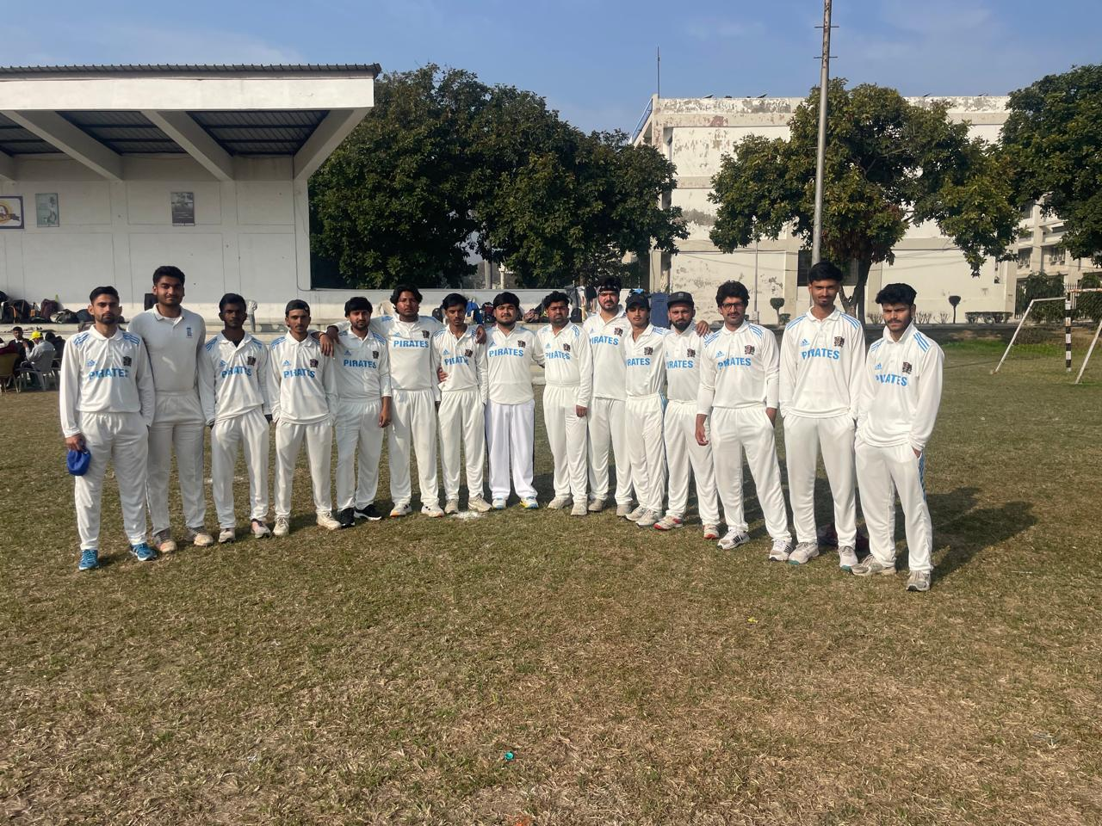

Second Innings Performance:
The match turned into a closely contested encounter. Both teams performed with great spirit and competitiveness. The host team demonstrated strong batting performance and strategic gameplay.In a thrilling finish, Baba Banda Singh Bahadur Engineering College successfully chased the target by scoring 105 runs in 17.5 overs, securing victory by a narrow margin.
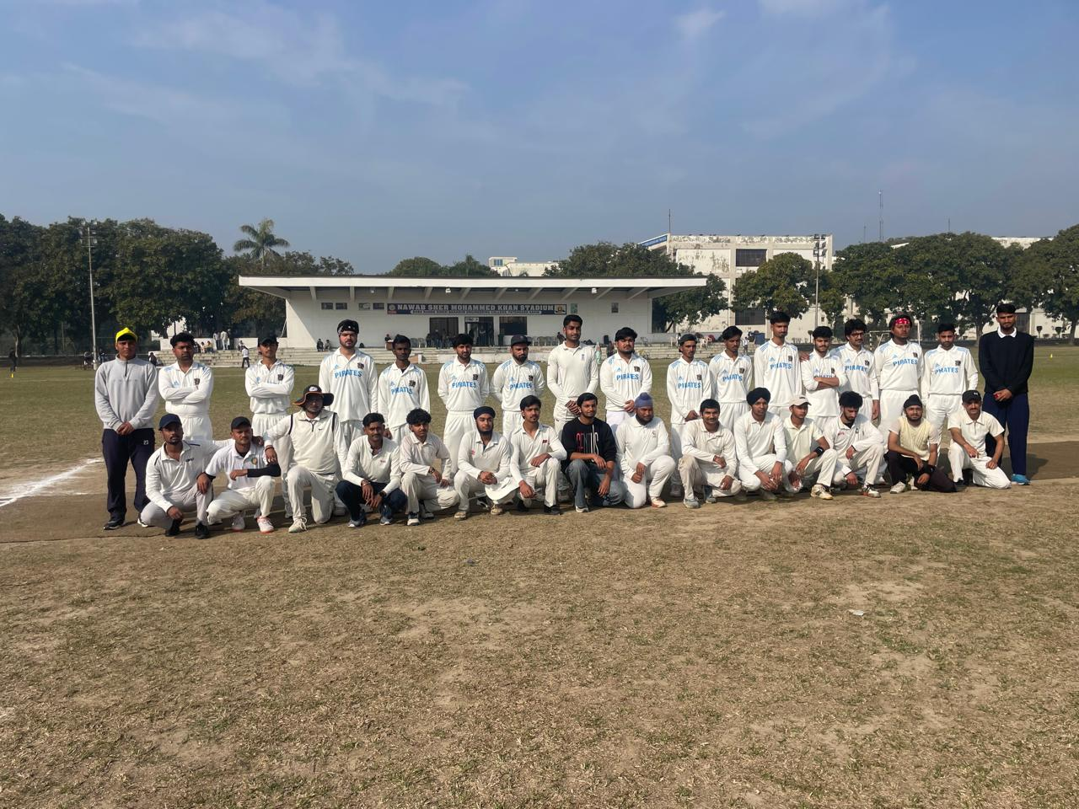
List of Participants
Sr No. | Name of Students (Class) | Sr No. | Name of Students (Class)
 | NIKHIL DOGRA | 8. | SOURAV
 | AKASH | 9. | YOGENDER
 | SHIVAM | 10. | IMRAN ALI
 | SOHAIL | 11. | SHIVAM YADAV
 | ZAKIR | 12. | RAJIT
 | NAZAKAT | 13. | ARNAV SINGH
 | MUSTAFA | 14. | MUNISH CHOUDHARY

Conclusion
Although our team did not secure the win, the match was highly competitive and reflected the dedication, sportsmanship, and teamwork of our players. The narrow margin of defeat highlights the strong performance and fighting spirit displayed by our team throughout the game.
The participation in this prestigious tournament provided valuable exposure, competitive experience, and an opportunity to enhance teamwork and strategic skills. The team represented Sachdeva College of Pharmacy with dignity, discipline, and true sportsmanship.
We remain confident that this experience will further strengthen our players and motivate them to achieve even greater successin future tournaments.

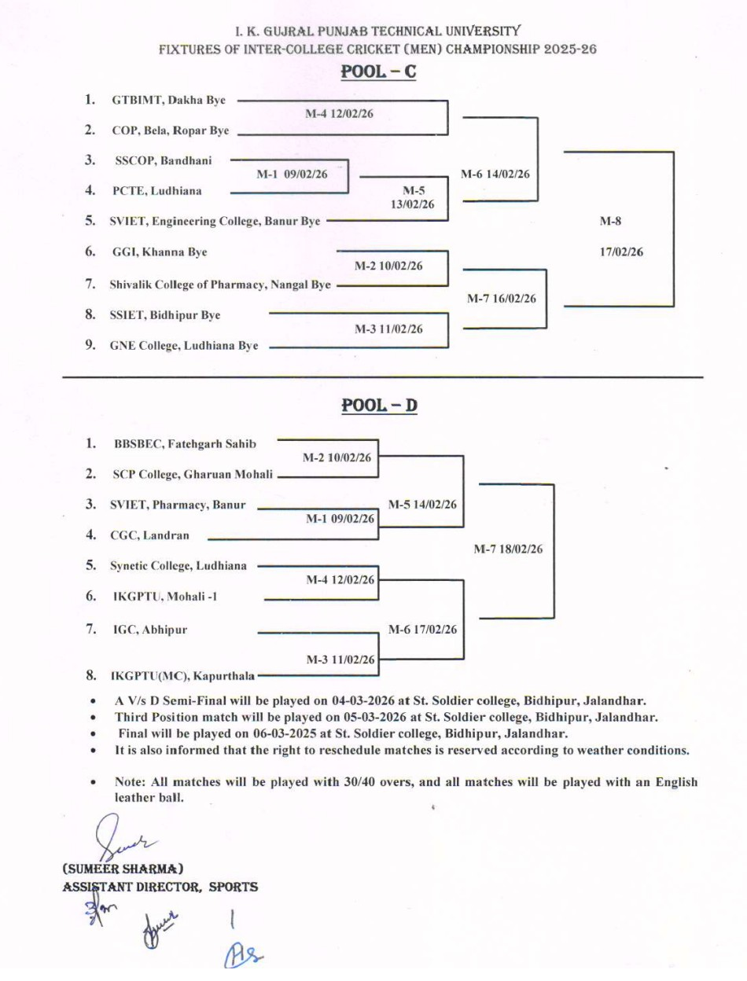

Principal HoD Person-in-charge(s)
Sachdeva College of Pharmacy, Mr. Gurinder Singh
Gharuan, Kharar (Mohali)

