Sachdeva pharmacy college’s students visited pharmaceutical industry
Sachdeva College of Pharmacy successfully organized an Industrial Visit to the two Pharmaceutical Industries via Venus Remedies Limited & Scott Edil Advance Research Laboratories Limited located in the industrial area of Baddi, Himachal Pradesh, India on Tuesday, Feb 13, 2024. A total of 40 students from semester 8th and 6th along with two faculty members namely Dr Shilpi Sachdeva and Mr. Imran Bhat accompanied the students for this industrial visit to understand the basic drug manufacturing process including production activity, quality control, quality assurance, packaging, management process, machine learning and technology to acquire knowledge and practical experience.
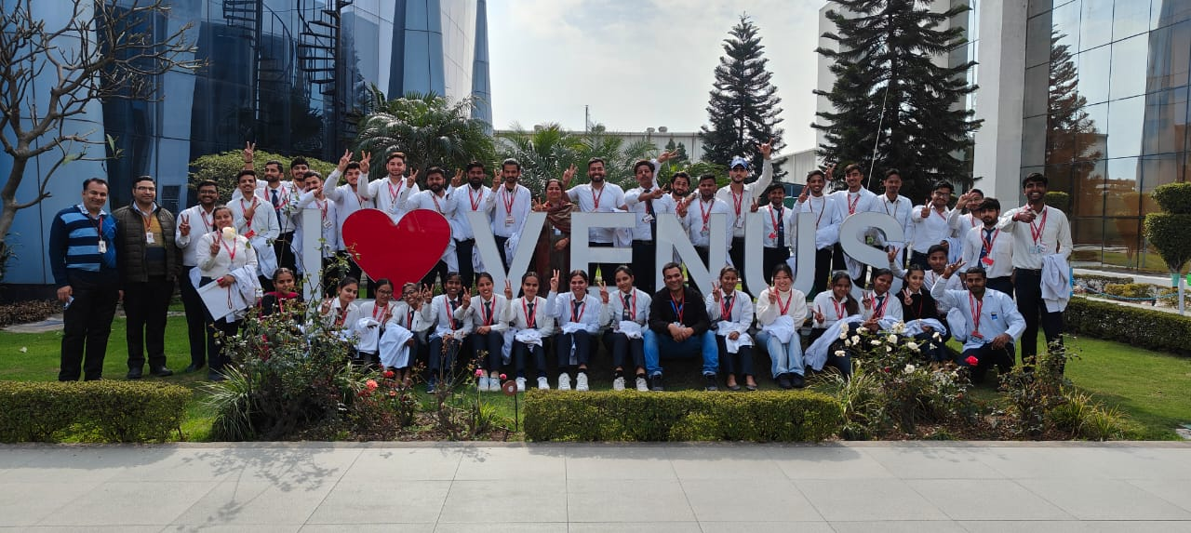

The tour started with a visit to Venus Remedies Ltd where the Industry Manager and HR hold a session with the students to apprise about the career opportunities in industry sector and also the drug products and services their company offers, since they are known for manufacturing anti-cancer drugs. Later students in two batches were toured to the manufacturing area under the supervision of a guide appointed by them to help the students for learning the actual drug manufacturing operations.
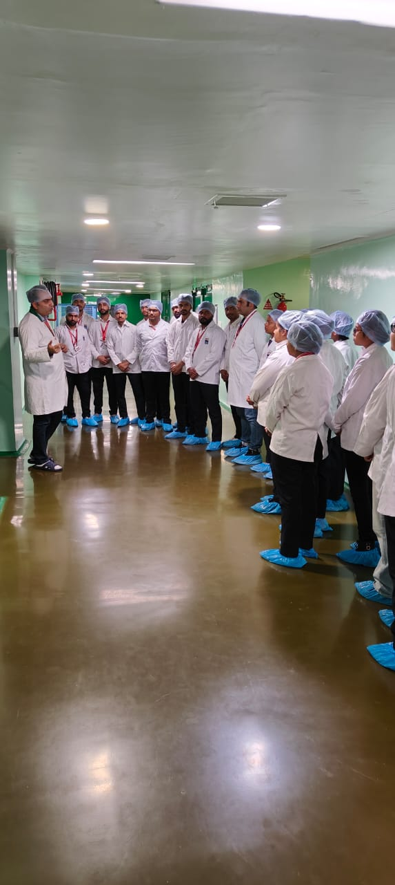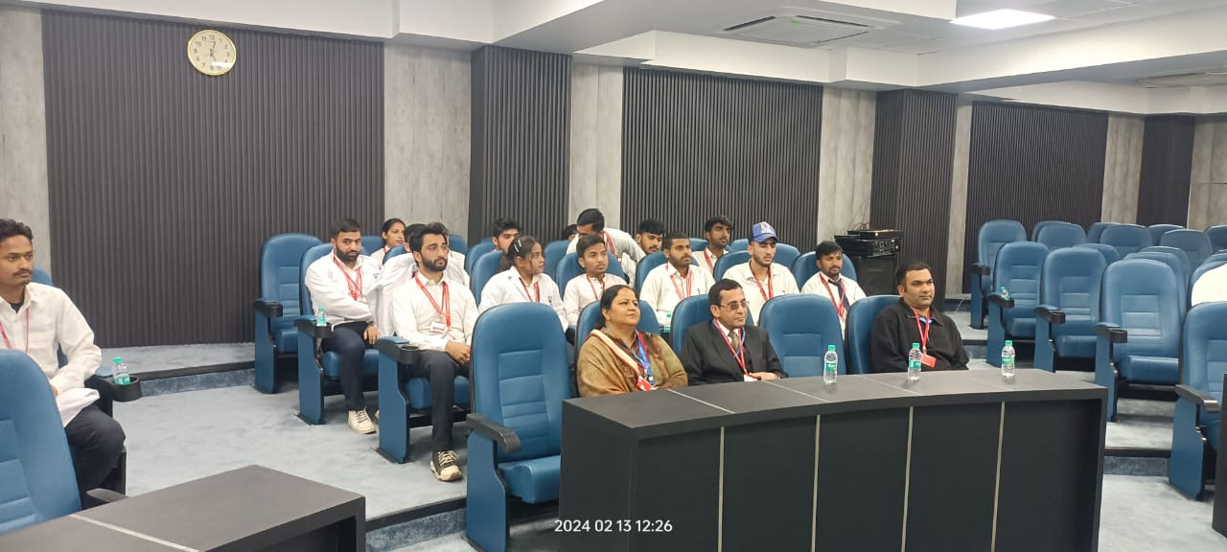
The tour ended with an another visit to a nearby pharmaceutical industry unit, Scott Edil which manufactures mainly antibiotics. Students again got equipped with a good knowledge of current manufacturing practices and latest research based innovations idea and practical knowledge in the domain of pharmaceutical industry.
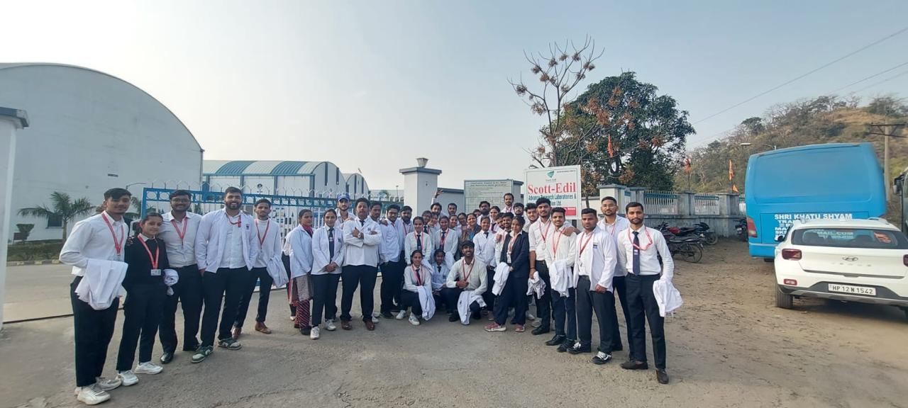

This Industrial visit overall gave a true picture of Pharmaceutical Industrial set up and practical drug manufacturing operations.
