Sachdeva Colleg eofPharmacy,Gharuan,KhararMohali Farewell Party- 2025

The One Last Hurrah! Title given by our students to the biding party for the passing out students of our college. Farewell party is a common event that takes place in almost every college and university to cherish the moment with all before starting the next chapter of life.

On 21.04.2025 around 11.00 am, the function begun at the decided Venue named Prankster Club in Chandigarh, sector 26, Punjabfollowed by fun games which were conducted by the juniors totheseniorssuchastaskslips, performing some said activities on songs etcetra. All the students were felicitated bythe Principal Dr.VK Gupta while addressingthe students, hebeautifullyquoted one advice to be a successful person in life and that was “Don’t let pride to take control of your nerves” then he explained the dilemmas which would be a barrier to the legal profession how the students should prepare themselves for their future endeavors and wished themwith his motivational speech. Juniors also gave some performances for their seniors like Shayari, Dancing, Singing etcetra.
At the end, based on student’s performances in farewell, respected judges, Mrs. Poonam Bhauta and Mrs. Reetika, announced names of Mr. Farewell and Miss Farwell were Mr. Shivam Sharma and Ms.Nancy Malhotra from B. Pharmacy, Mr. Personality and Miss Personality were Mr. Davinder Singh from D. Pharmacy and Ms. Harpreet Kaur from B.Sc (MLS).

Someglimpsesoftheevent:
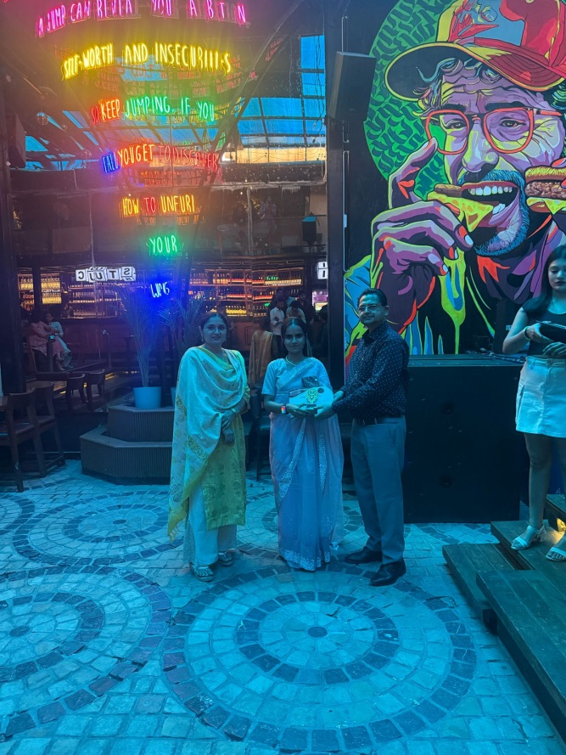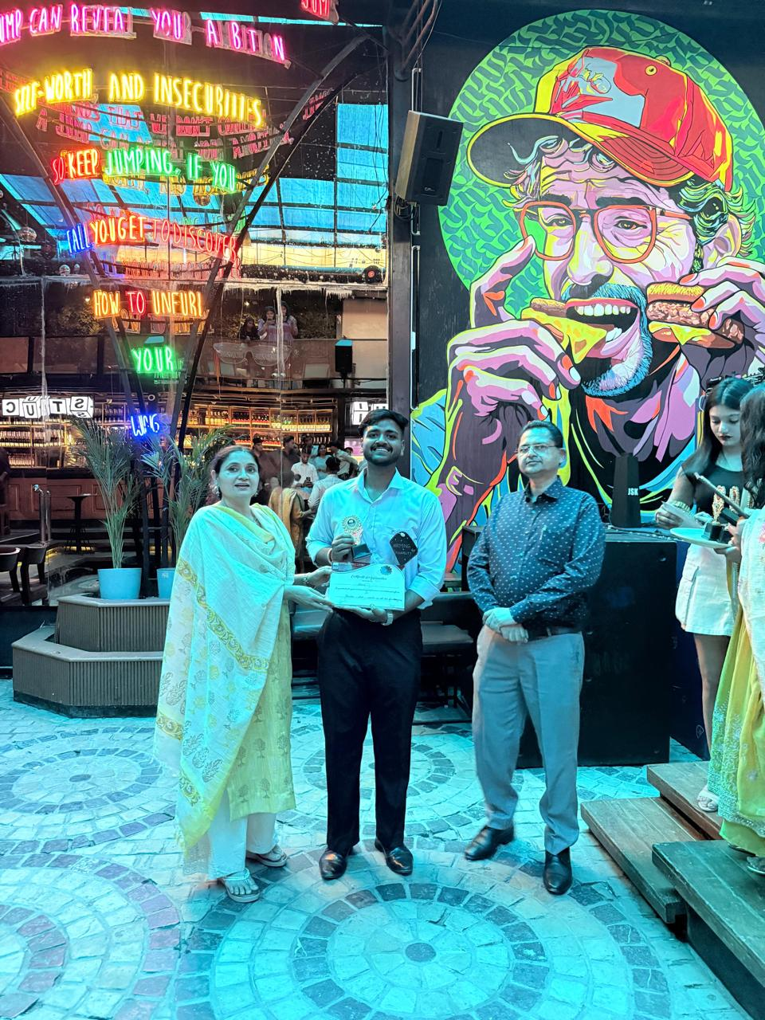

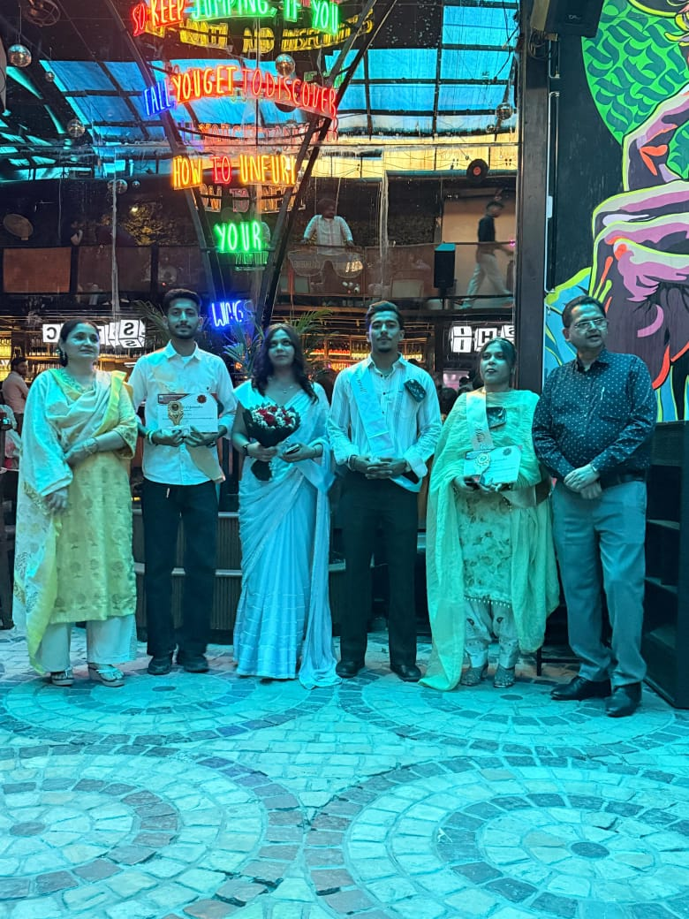

Prize Distribution to the Mr. and Miss farewell 2025

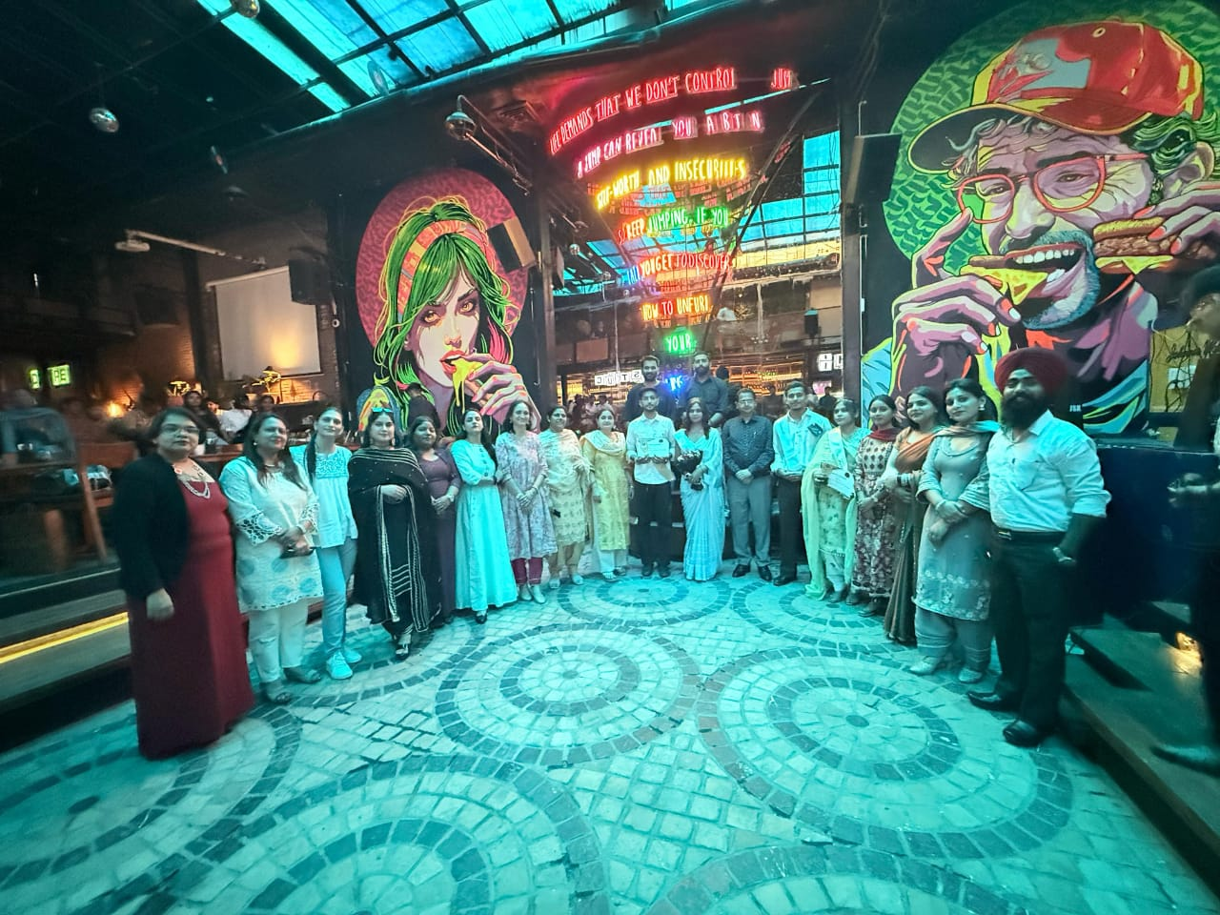

Group photo of all faculty members with Mr. and Miss farewell

