SACHDEVA COLLEGE OF PHARMACY, GHARUAN

ANTI- RAGGING DAY (week)-2025
On (12 to 18) 24th of Aug 2025, Sachdeva College of Pharmacy observed Anti-Ragging Day as part of a creating awareness to reinforce its commitment to provide a ragging-free campus. The event focused to educate students about the negative impact of ragging and to foster an environment of mutual understanding, cooperation and safety for all. The main objective for celebrating this day is to sensitize the student mind about the harmful effects of ragging. Along with this, to let the students know about the institution's strict anti-ragging policy and procedures. This also ensures them to enthusiastically participate in creating a safe and supportive learning environment. The day included the formal pledge taken by all students and staff to uphold the dignity of their peers and contribute to a ragging-free environment. College also organized competitions like Poster Making to encourage creative expression against ragging. In addition, a Presentation was held by a student of 7th semester to highlight the serious implications of ragging, including how to file a complaint against a person who involve in ragging.
Expert talks were done by Worthy Principal Prof. Dr. V.K. Gupta and respected HOD Dr. Vandana Kharb to provide guidance on the seriousness of ragging, the anti-ragging policies of the institution, and the legal consequences. To reiterate, the event successfully raised awareness and left a lasting impression on students, motivating them to stand against ragging. Also, participants actively involved with the activities, showing their commitment to a positive campus culture.
SCHEDULE OF THE EVENT:

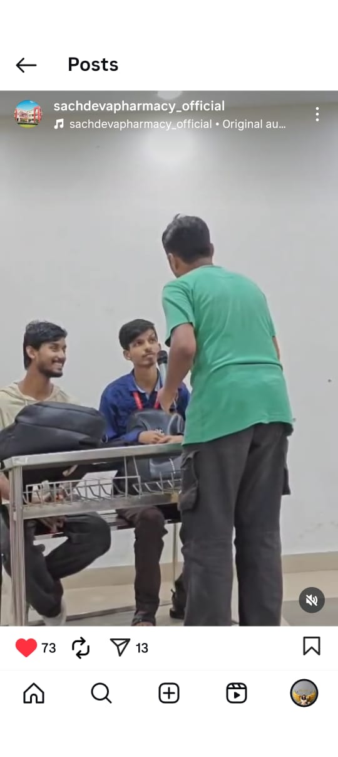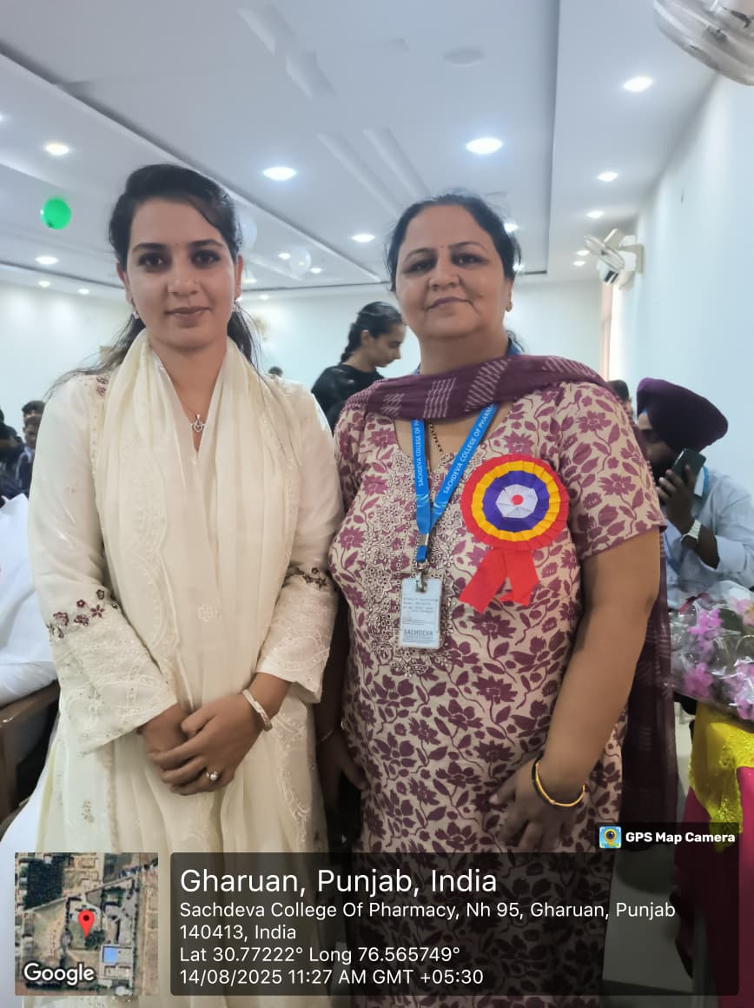
Skit by Students and HOD ma’am with Student

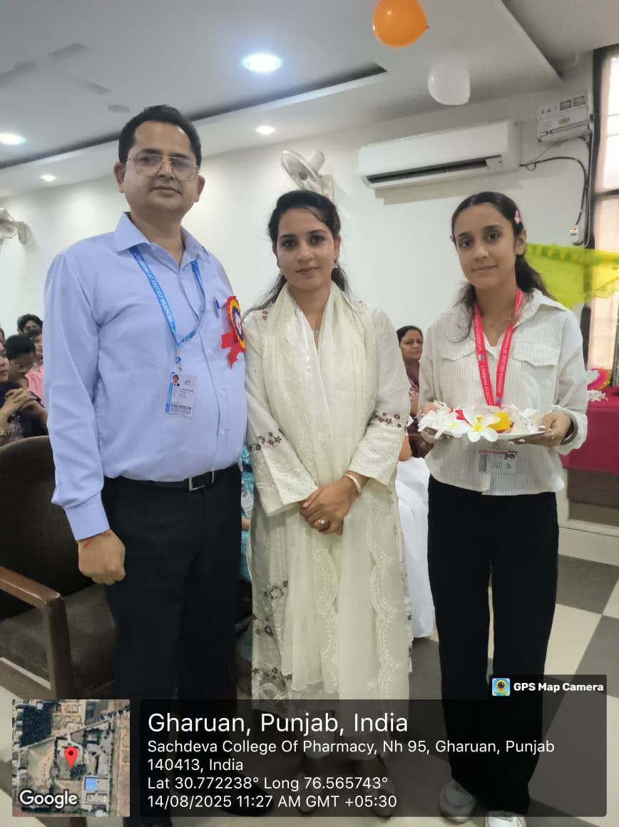
Welcome by students Principal Sir and HOD Ma’am
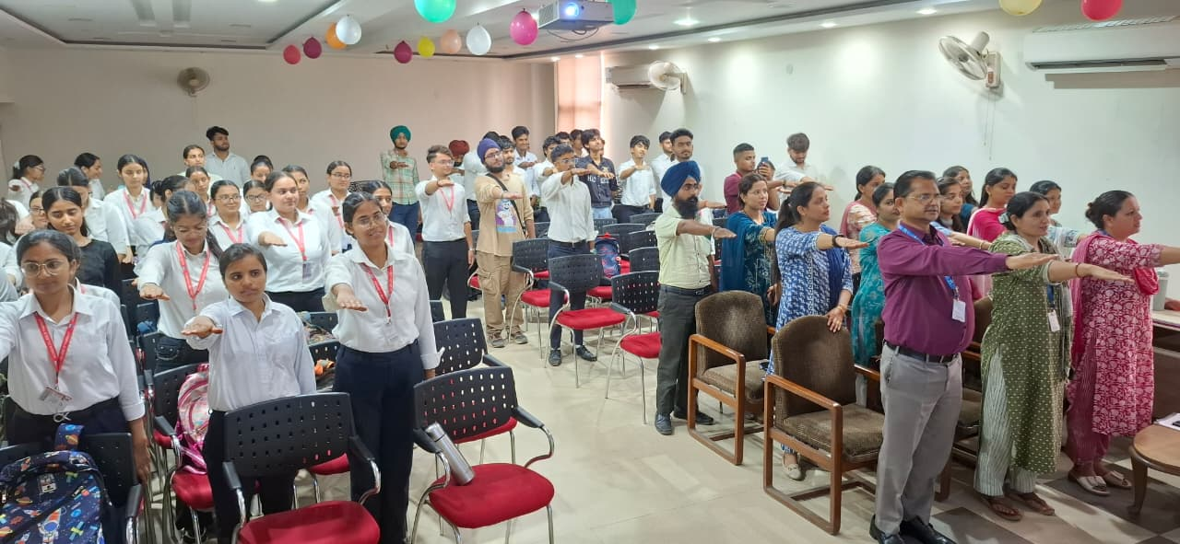
Pledge by Students and Staff

