SACHDEVA COLLEGE OF PHARMACY, GHARUAN

3RD NATIONAL cGMP DAY-2025
It is the responsibility of every Pharmacist to know his/her worth by celebrating and reminding those days which are meant to aware people in the medical field. Taking this in mind, Sachdeva College of Pharmacy, Ghauran always welcomes the idea to celebrate those marked days with great enthusiasm and joy. This time, on 10th of Oct 2025, College celebrated 3rd National cGMP Day actively by motivating their students to know about the detailed information of cGMP and its role in Pharmacy. For this purpose, college authority invited a very renowned and expert personality for a Guest Lecture from industrial background Mr. Rajeev Singh Rana who has dedicated his entire life in the field of Pharmacy. He was the speaker of the day who delivered his lecture on the theme ‘cGMP Training Roadway: A Pathway to Pharmaceutical Quality and Compliance’. Moreover, he put his all efforts to give detailed description of its every part, requirements and need in Pharmaceutical Industries. Further, he also covered topics like ICH Guidelines, its types and validation. In addition, the speaker satisfied the questions asked by the students and the faculty members at the end. At last, Principal Sir Prof. Dr. V.K. Gupta appreciated the speaker for giving insights into the deep knowledge related to this topic. Students were also awarded for the efforts they did in various cultural activities held in the campus. Overall, it was an interactive session.

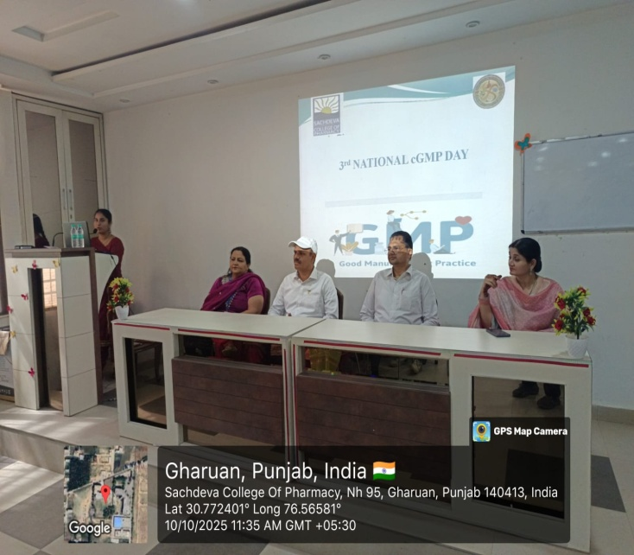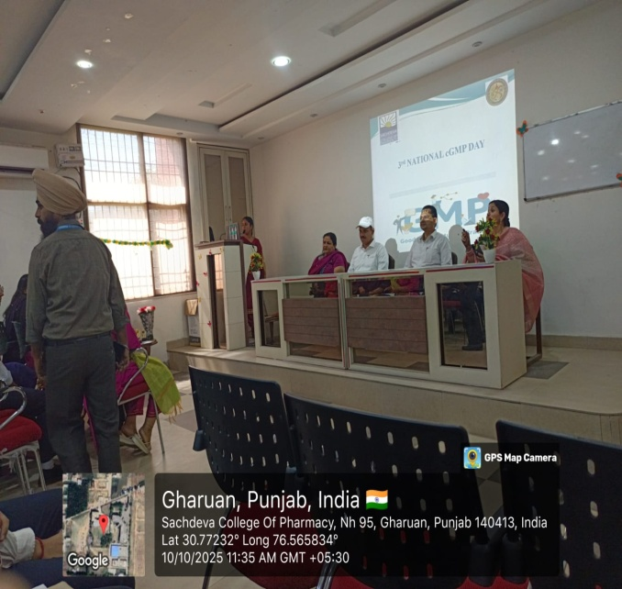
Welcome Address to the Invited Guest

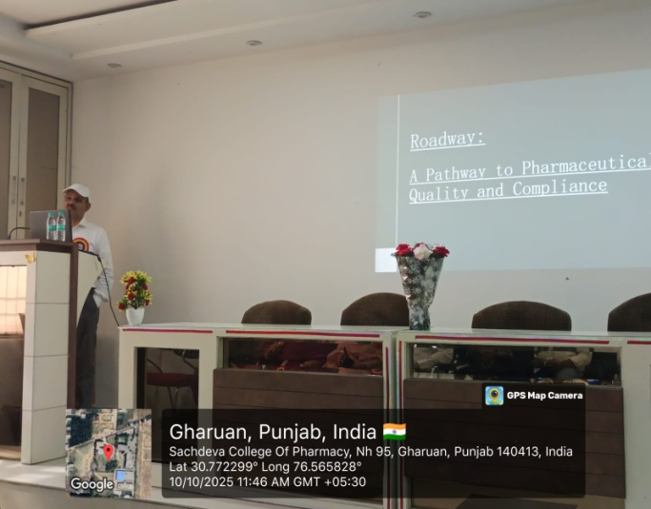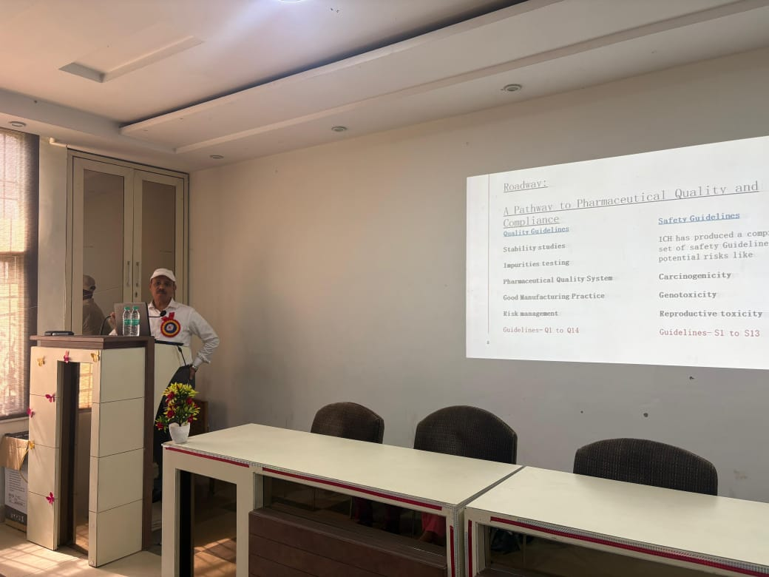
Speaker delivering lecture on cGMP

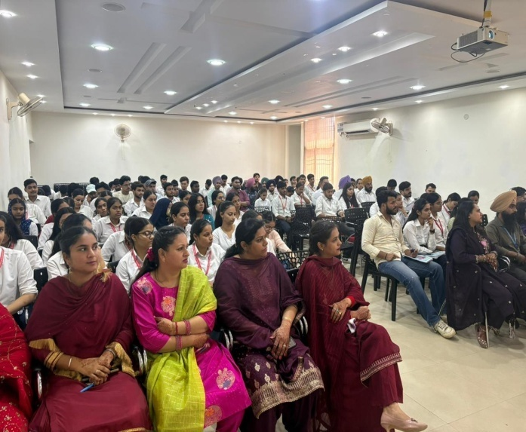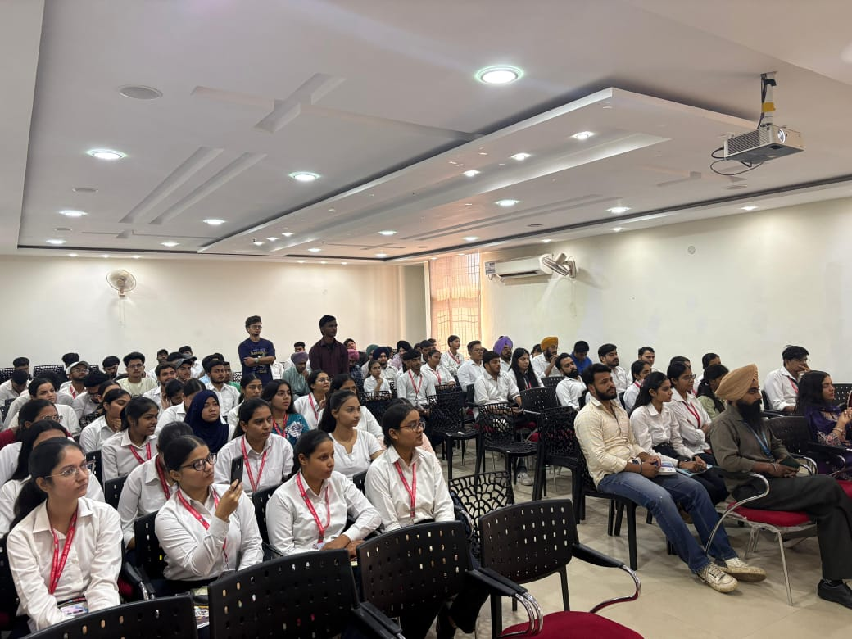
Faculty and students attending lecture

