SACHDEVA COLLEGE OF PHARMACY, GHARUAN

GUEST LECTURE -2025
It is paramount to uplift oneself from time to time for the holistic development of the individual and society. By taking this as a motive, Sachdeva College of Pharmacy, Ghauran organised an expert lecture on 29th July 2025, by Mr. Rajpal Singh on the theme "Current Challenges and Remedies for Career Growth". It was a complete guide for the faculty members to make them more enthusiastic to come out of their shells and work on their brighter side. Teachers have to work on more project work, publish papers, go for research and dive deep into the ideas of promoting students' growth. He added that they should focus on becoming a professor from a lecturer by giving very beautiful and scientific examples of LOCI, which means Loop of Continuous Improvement. By this, he wanted to explain that the Continuity of a professor's growth every year is a must to face the future challenges in the educational field. This can help to address the difficulty of students in any way. In addition, when the growth goes on on both sides, that is, of teachers and students, the growth of the institute will be the end result. In addition, the only responsibility of faculty members is to uplift their workplace with their progressive nature and support. To conclude, our Worthy Principal Prof. Dr. V.K. Gupta offered the vote of thanks to the guest speaker to motivate faculty and share his precious time with us.

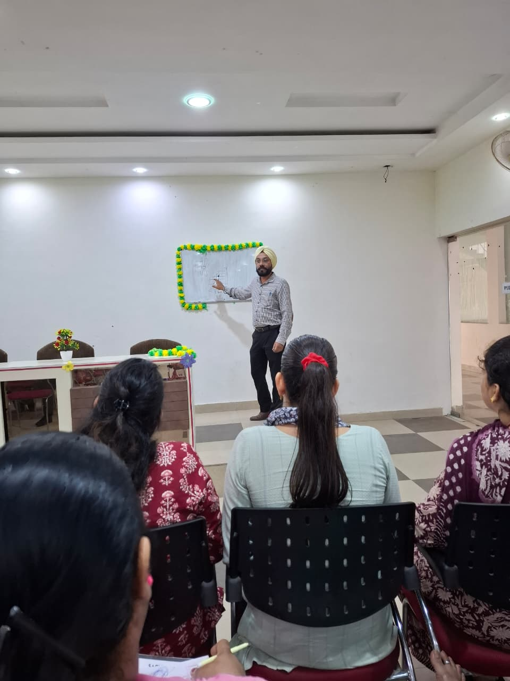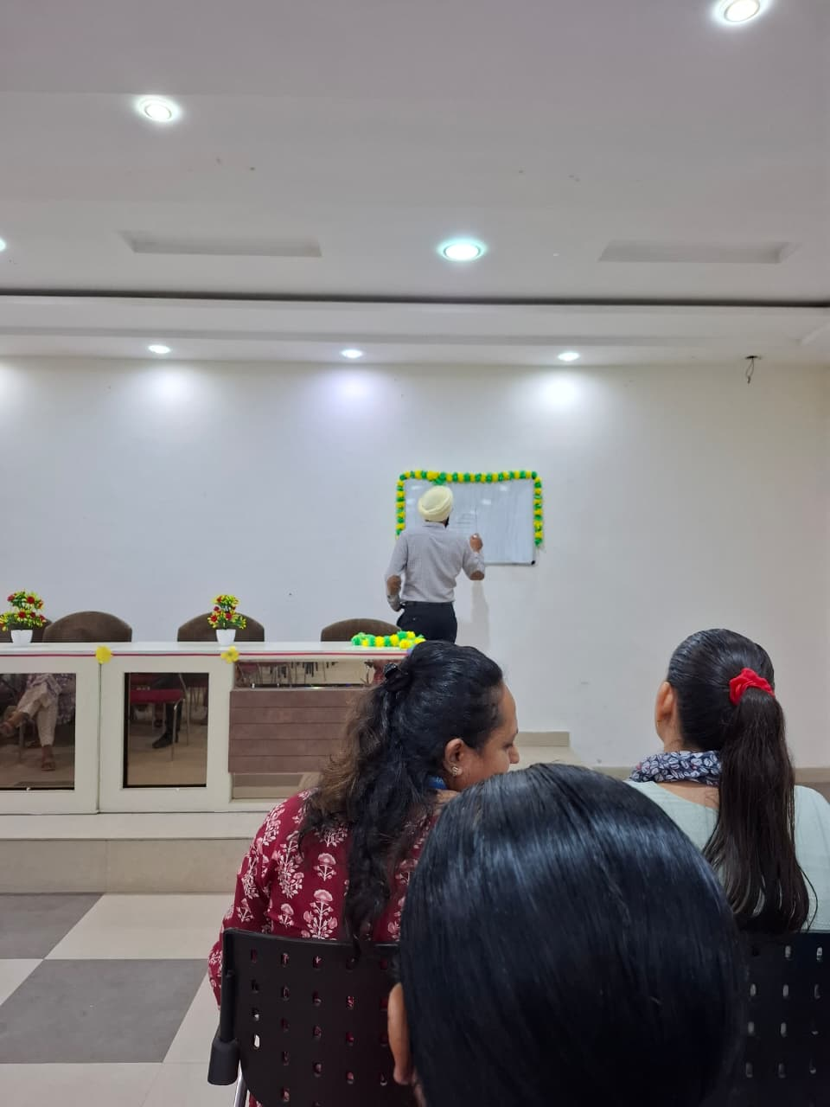
Mr. Rajpal Singh Delivering Lecture to the Faculty

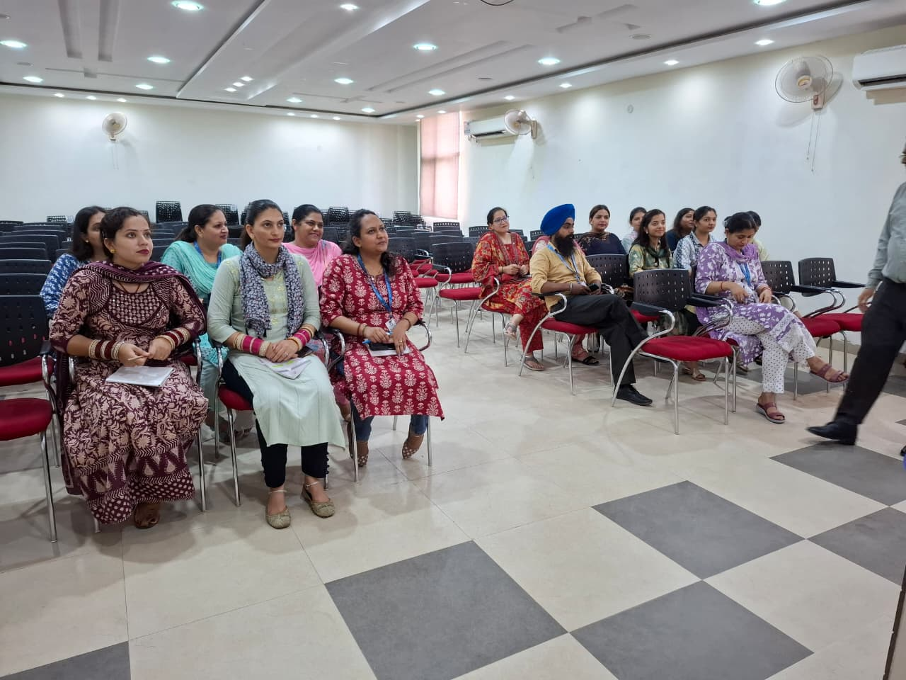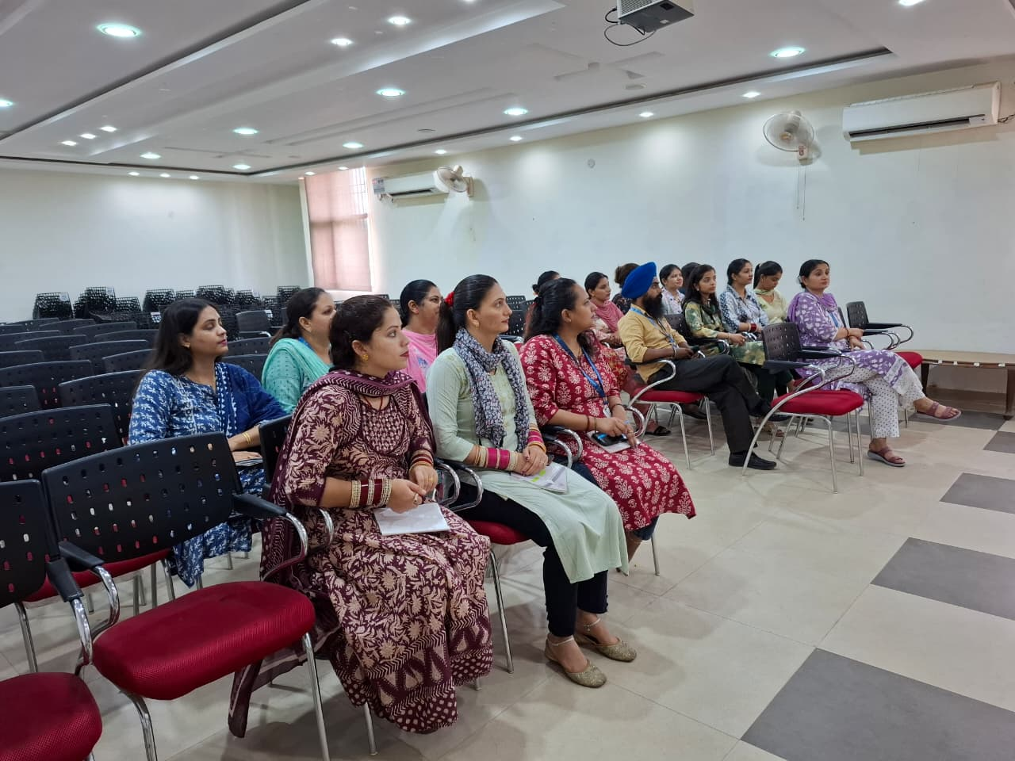
Faculty attending Lecture along with HOD

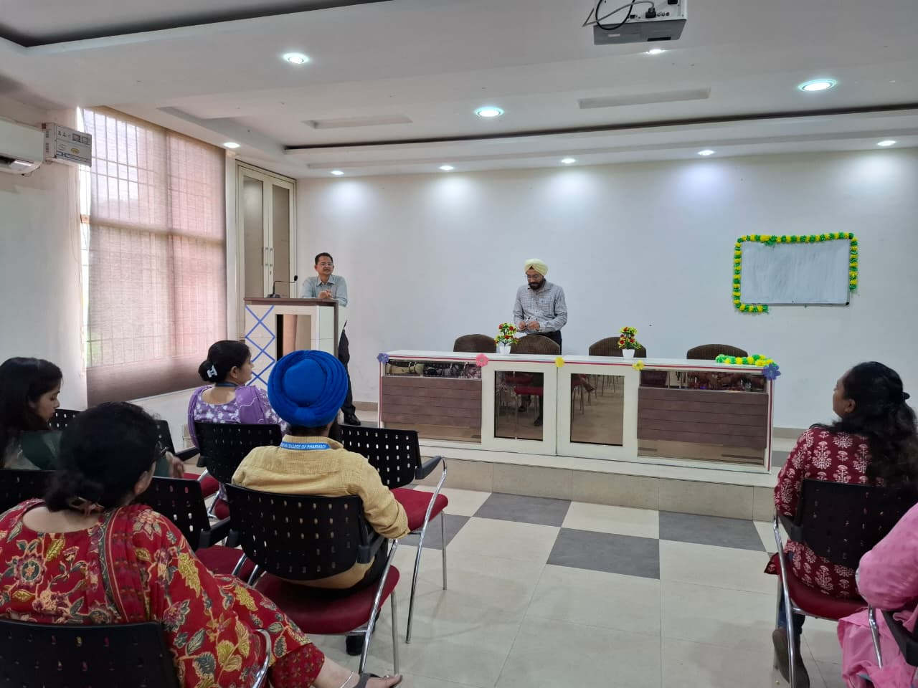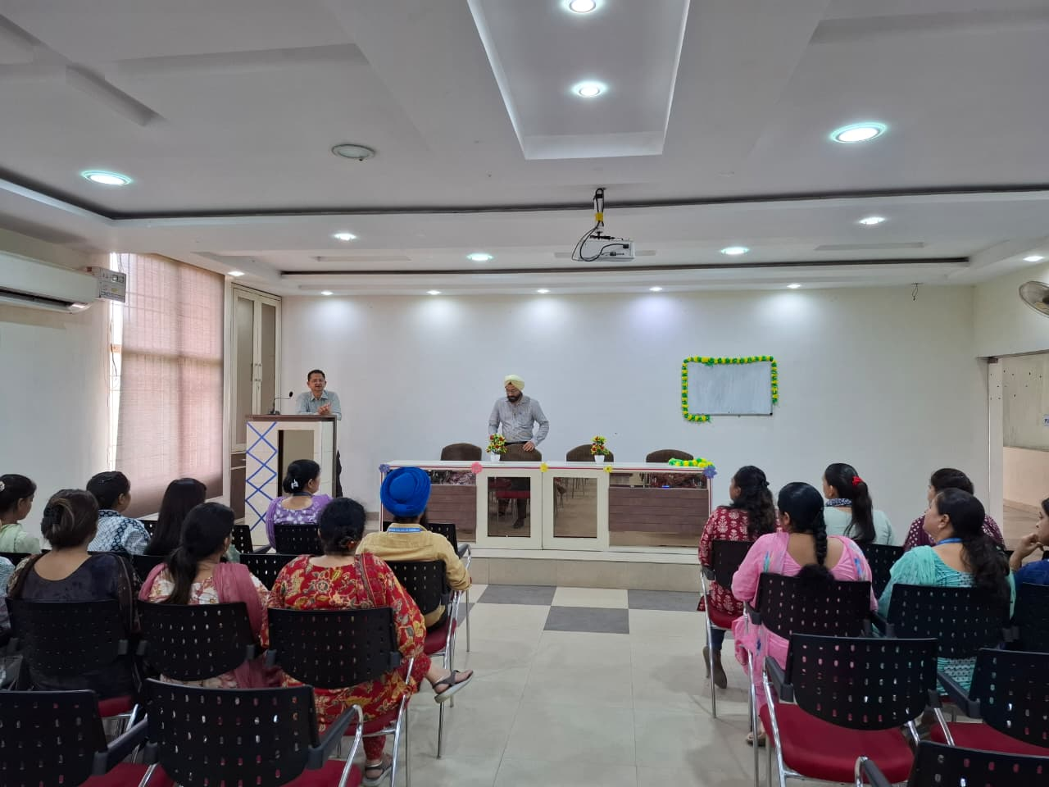
Vote of Thanks by Principal Sir

