SACHDEVACOLLEGEOFPHARMACY,GHAURAN SPORTS MEET-2025

On 6th and 7th of February 2025, the campus had resonated with the vibrant spirit of Sports Meet 2025. Students had demonstrated their prowess across a diverse array of indoor and outdoor sports, ranging from Cricket and Volleyball to Kabaddi, Kho-Kho, Tug of war, Chess, Carrom, and beyond. The spirit of sportsmanship echoed through the campus as students competed with zeal and enthusiasm. It was not just about winning but fostering camaraderie and mutual respect, exemplifying the essence of true sportsmanship.Beyond the thrill of victory, the Sports Meet underscored the vital role sports play in shaping a student's life. From fostering discipline to instilling teamwork and resilience, sports offer valuable life lessons that extend far beyondthe playing field.As we celebrated, the achievements and triumphs of our athletes,let's also acknowledge the significance of sports in nurturing well-rounded individuals. Kudos to all participants for making Sachdeva College of Pharmacy, Ghauran Sports Meet 2025 an unforgettable testament to the power of sports. The sports event was inaugurated by ourWorthy Principal “Dr. V.K. Gupta”, Dean student welfare “SP Goel” and HOD “Dr. Vandana Kharb”. Various sports programs were organized on two days in which students participated according to their interests. All the games were organized in our college playground. On second day GS Sandhu (National Ex Boxing Coach and Padmashri and Guru Dron Acharya Awardee) was chief guest and Mr. Kamal Taneja worked in Airforce and now SHO in Gharuan(Mohali) was Guest of Honor. Dr. Vandana Kharb (HOD) gave welcome speech to chief guest.

TheScheduleoftheSportsmeetis mentionedbelow:-

SCHEDULE:

Day 1
9:00am - 9:30am | 9:30am - 10:00am |  | 10:00am-10:30am |  | 10:30am - 11:00am |  | 11:00am -12:30pm |  | 12:30pm - 01:00pm |  | 01:00pm - 01:30pm |  | 01:30pm - 03:30pm |  | 03:30pm - 04:10pm
March Pass & National Anthem | Sprint Race- 100m |  | Sack Race |  | 3- Leg Race |  | Badminton |  | Shot Put |  | Lunch |  | Volley Ball & |  | Football
Welcome Speech |  |  |  |  |  |  |  |  |  |  |  |  | Kho- Kho (Girls)
 |  |  |  |  |  |  | Chess &carrom
Day - 2
09:00am - 01:00pm |  | 01:00pm - 01:30pm |  | 01:30pm - 01:50pm |  | 02:00pm - 04:00pm |  | 04:00pm - 04:10pm
Cricket |  | Lunch |  | Arm Wrestling |  | kabaddi |  | Prize distribution
 |  |  |  | Push ups

EventCo-ordinators: Mr Imran Bhat,Mr.PankajKumar
Students Co-ordinator: Mr. Prashant
Photographyteam:,Mr.Yash

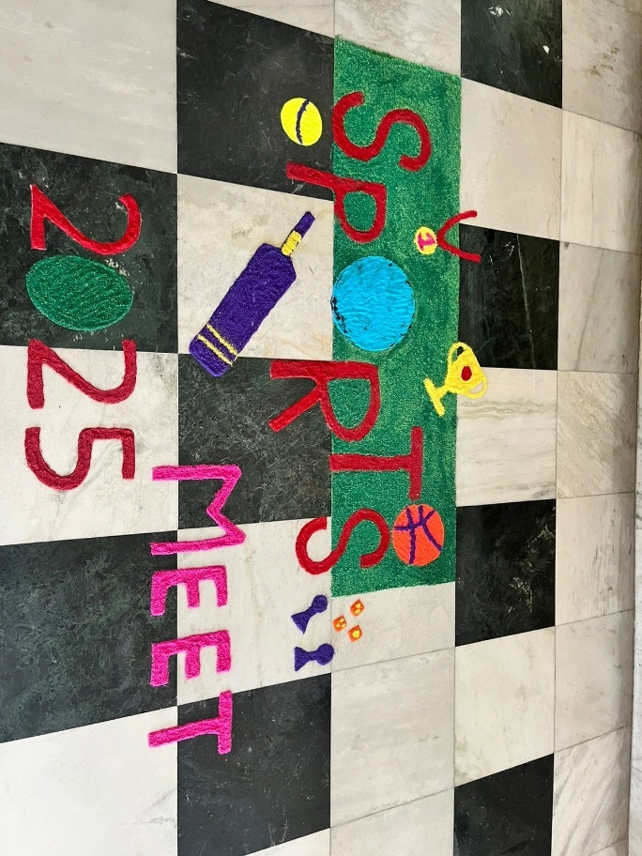

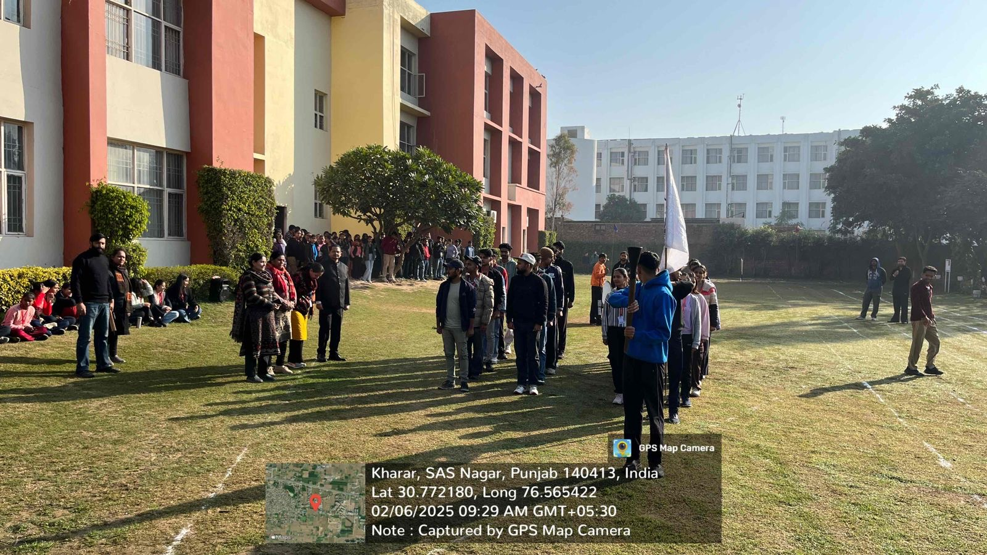
Parade

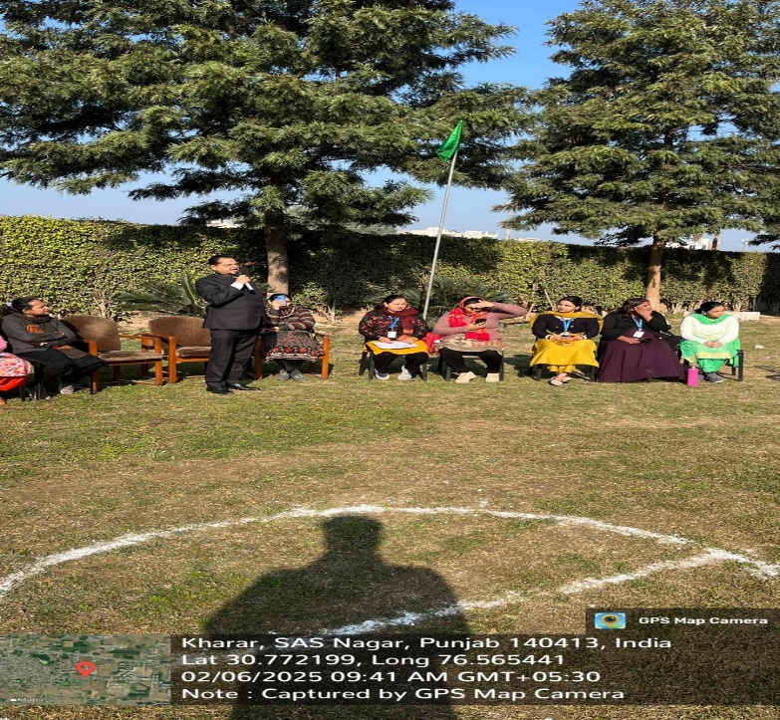
Event Opening Speech by Principal: Dr. VK Gupta

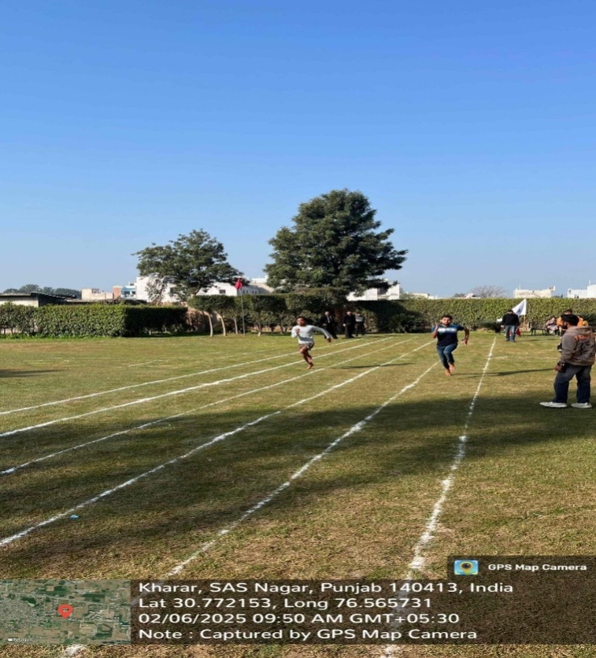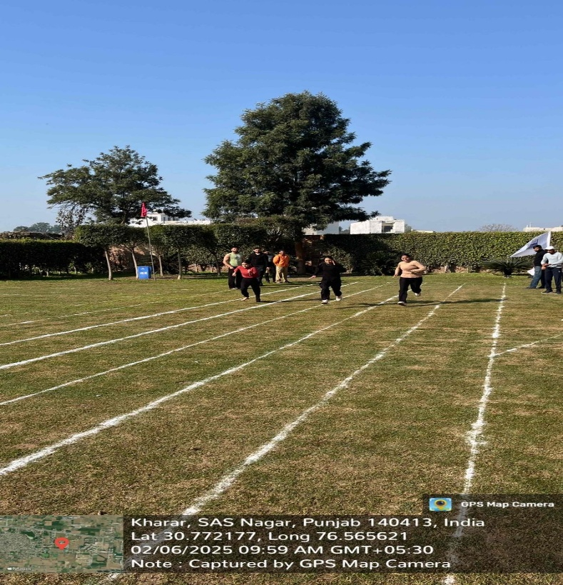
Boys: 100 Meter Race Girls: 100 Meter Race

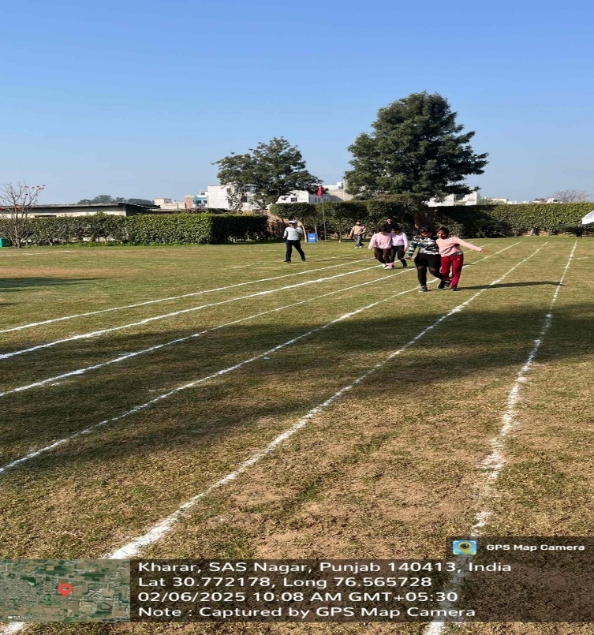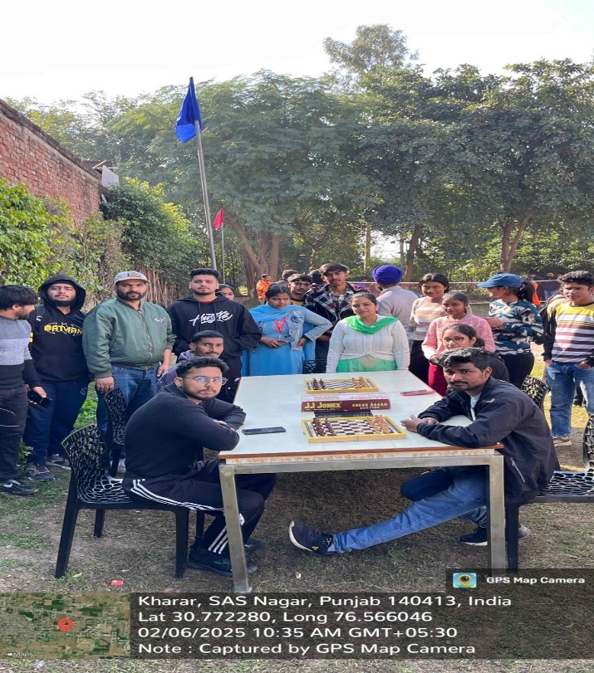
Three Leg Race By: Girls Chess and carrom By Students

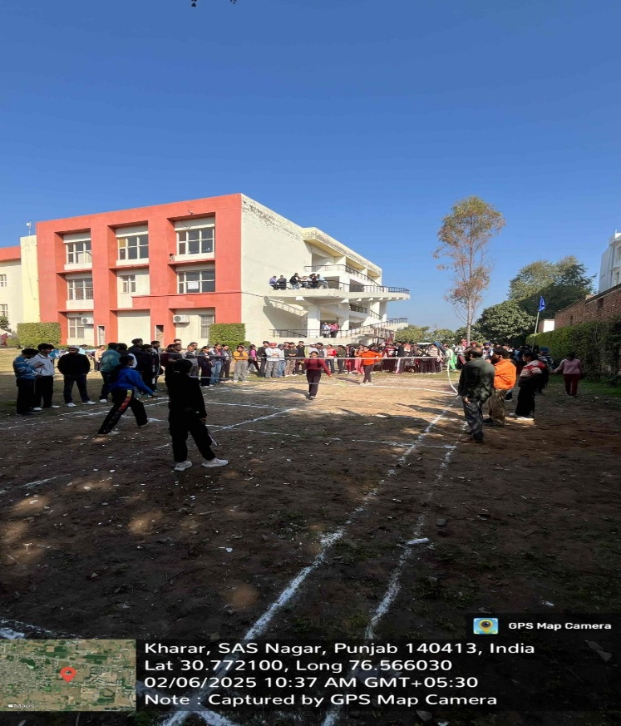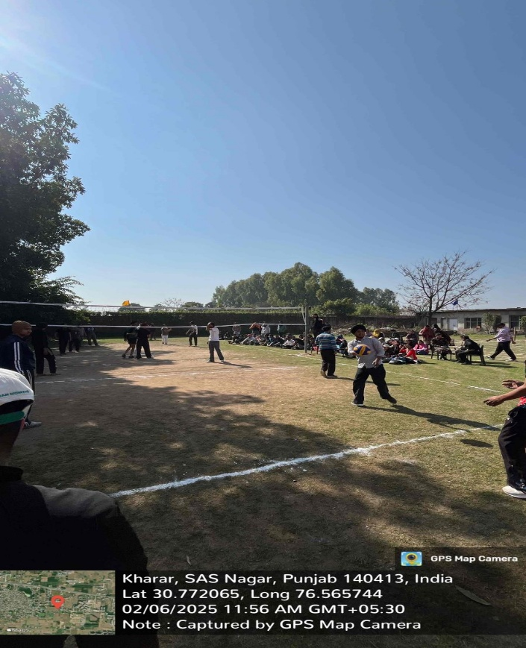
Badminton Boys Volley Ball
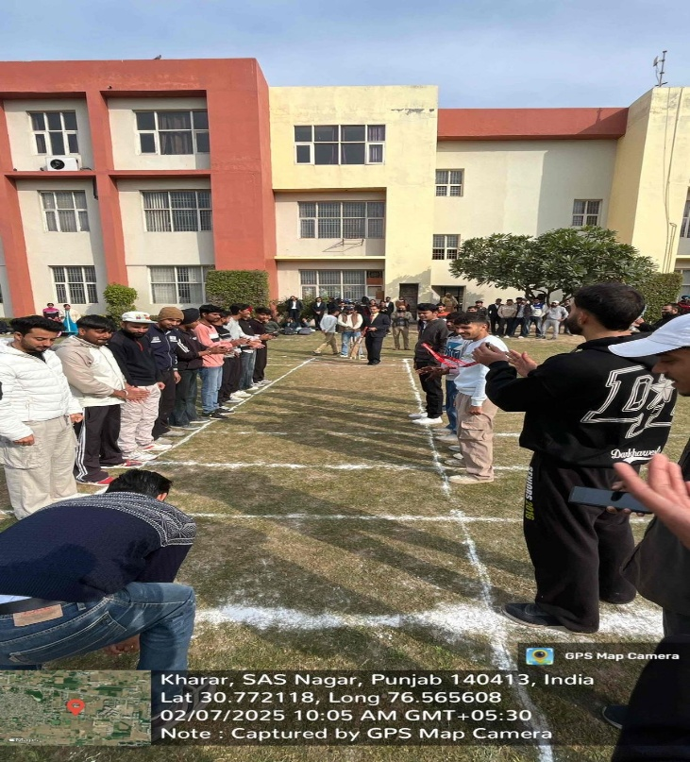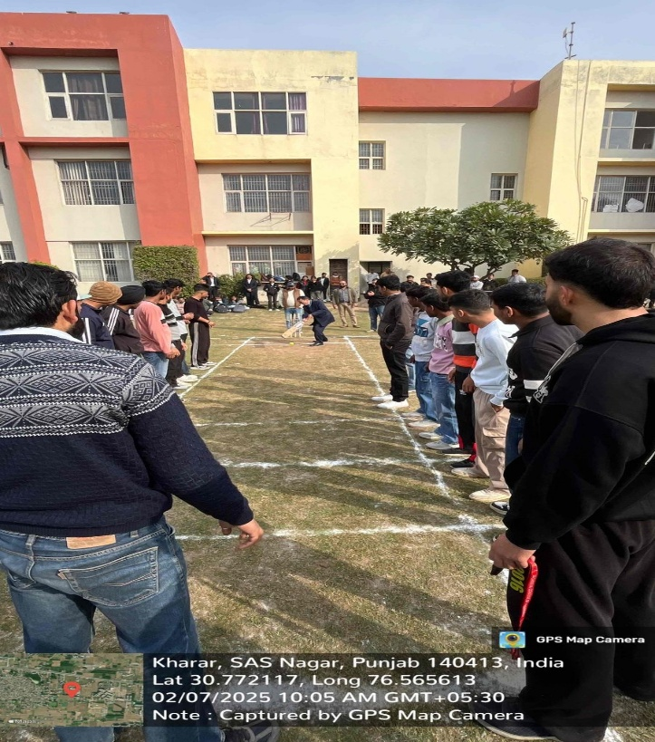

Opening of Cricket By: Principal (VK Gupta) and Dean Students Welfare (SP Goel)

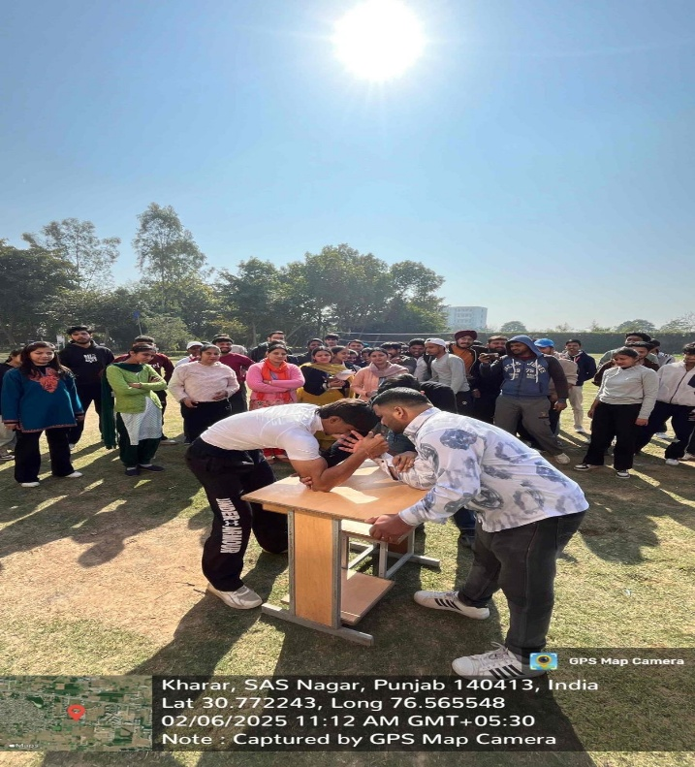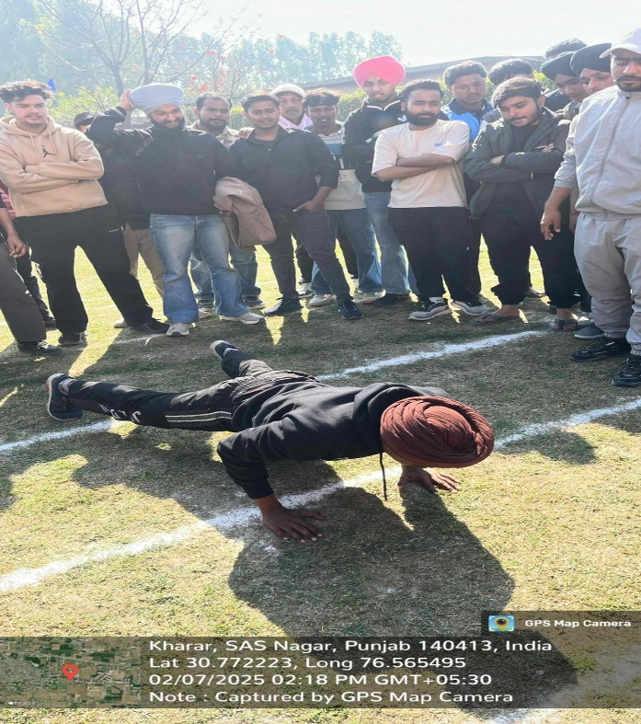
Boys Arm Wrestling Boys Push-ups
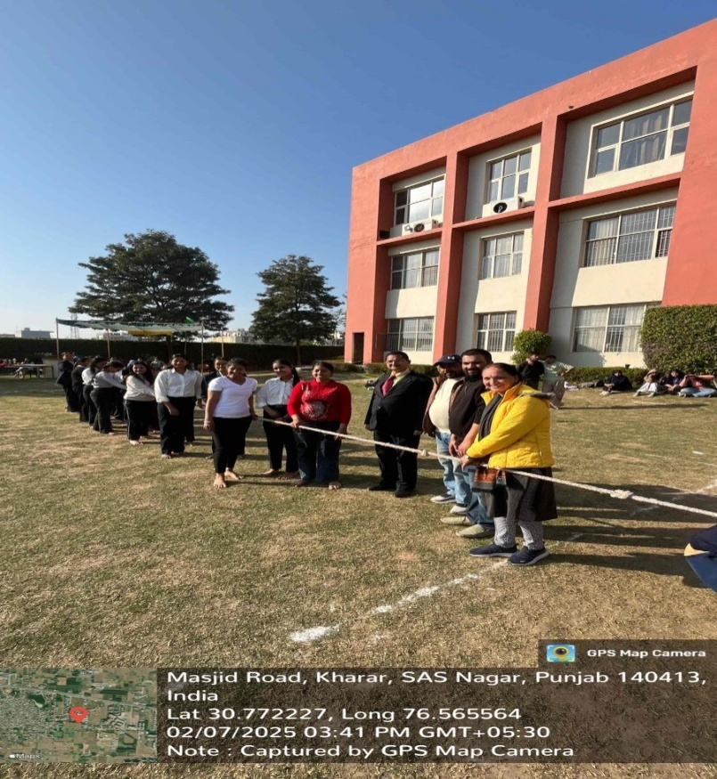

Tug of War By Girls

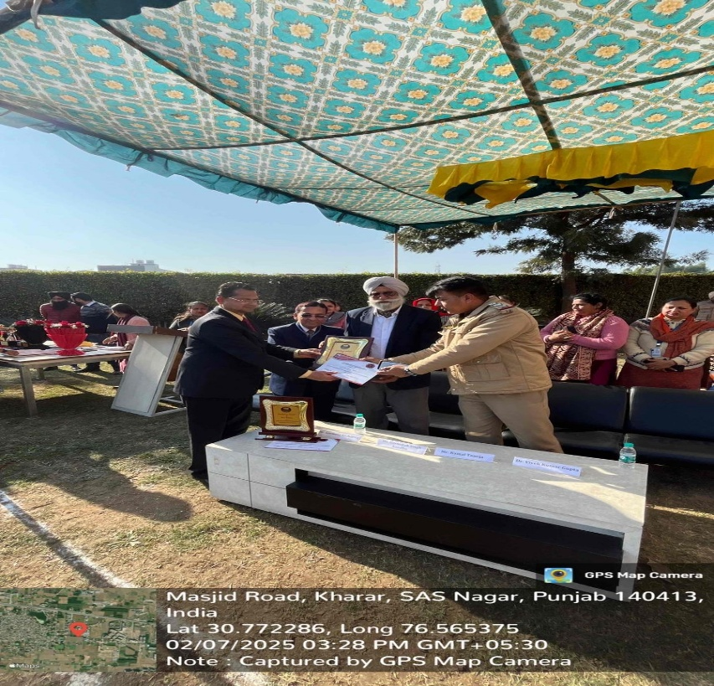
Guest of Honor by: Principal (VK Gupta) and Dean Students welfare (SP Goel)

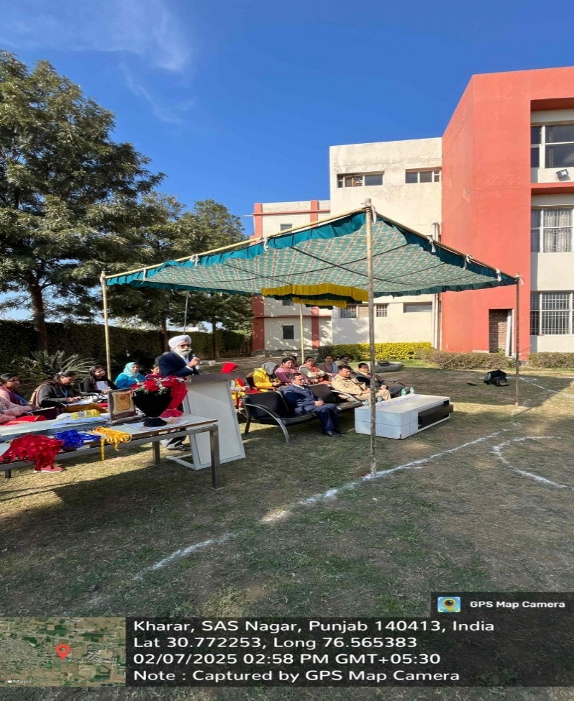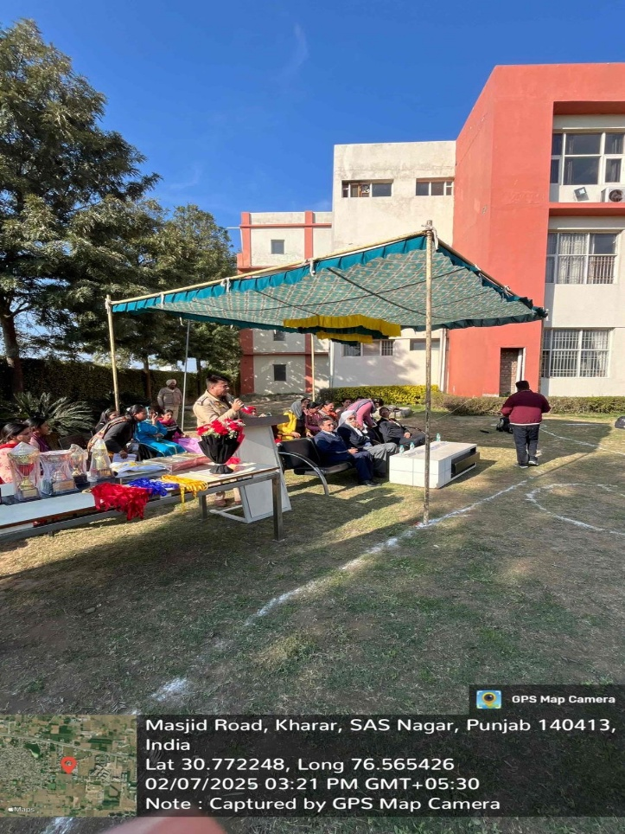
Speech By: GS Sandhu Speech By: Mr. Kamal Taneja

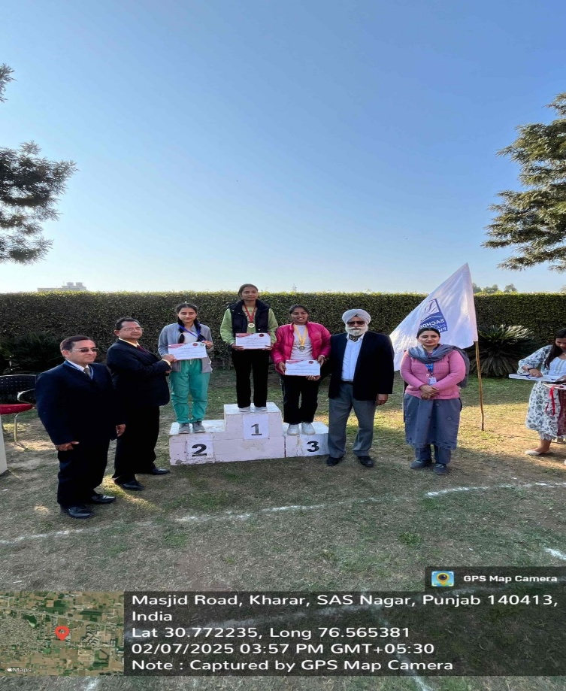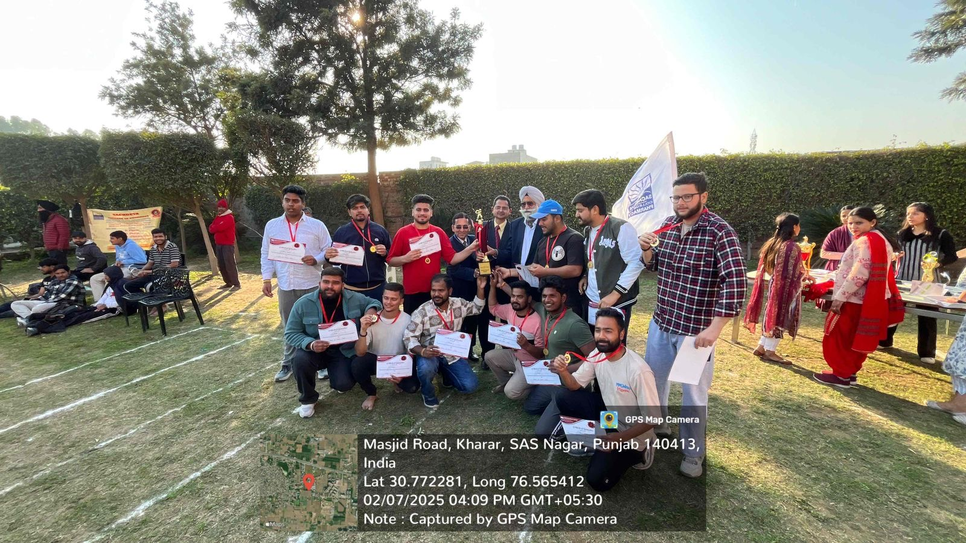
Prize Distribution to Winners by Chief Guest
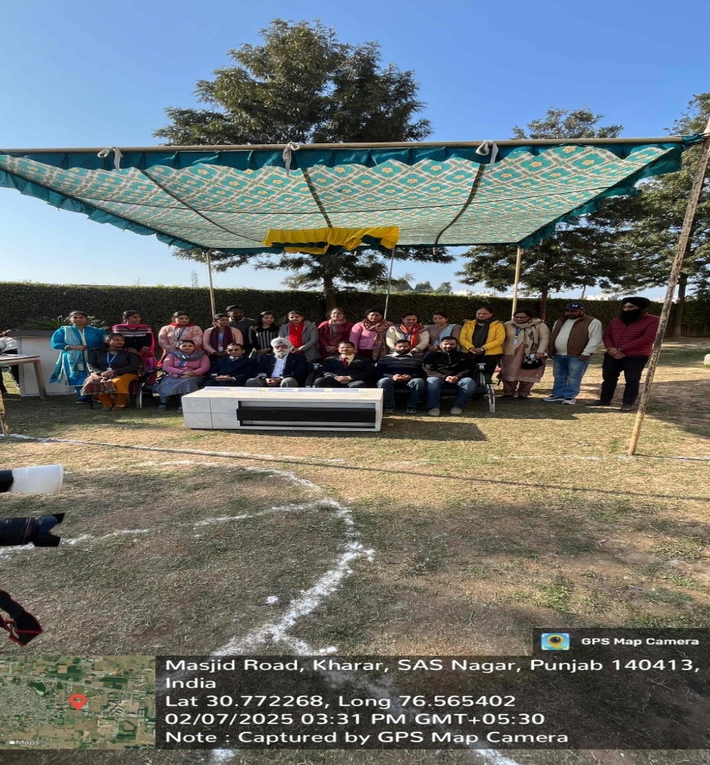
Group Photo Of Chief Guest with All Faculty Members

