SACHDEVA COLLEGE OF PHARMACY, GHARUAN

WORLD HEPATITIS DAY -2025
28th July, 2025 is celebrated as World Hepatitis Day under the theme Hepatitis: Let’s Break it Down. Being in the healthcare field, it is our responsibility to celebrate and raise awareness among people regarding this deadly disease. So, we as a part of Sachdeva College of Pharmacy, Ghauran, celebrated the day with several activities. We began with an oath, followed by speeches, and PowerPoint presentations by the students. This year's theme was "Hepatitis- Let's break it down". All our activities were centred around this theme. Students not only realised the value of health but also decided to keep others healthy by guiding them in the right way. The session ended with the valuable words of our worthy Principal, Prof. (Dr) VK Gupta, that awareness begins at home, and he encouraged everyone to spread the word about this disease to their family, society, and beyond. We, the pharmacists, should not forget how relevant and crucial our role is in keeping people aware of fatal diseases. India has a major number of patients suffering from Hepatitis, he added. The event concluded with the National Anthem, where all staff members and students stood together to honour our nation.

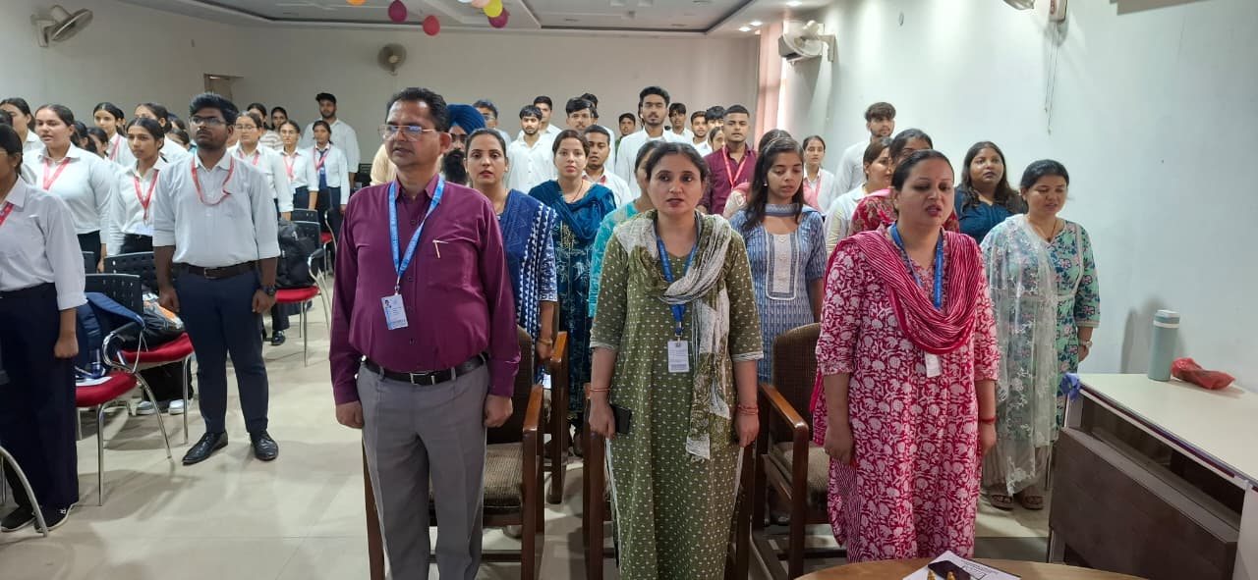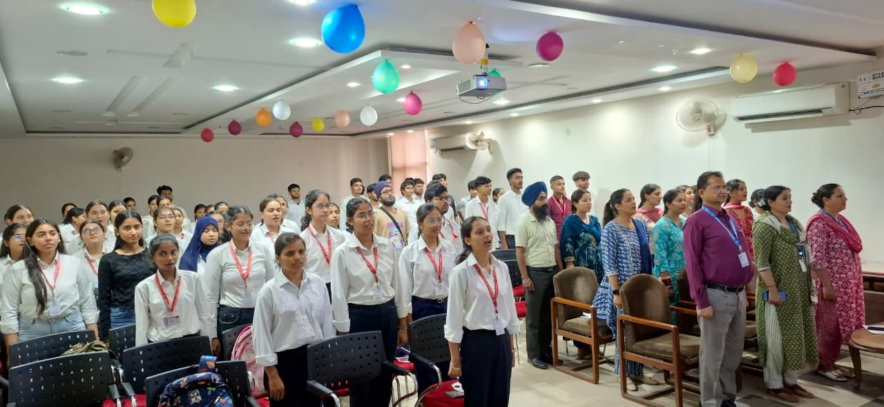

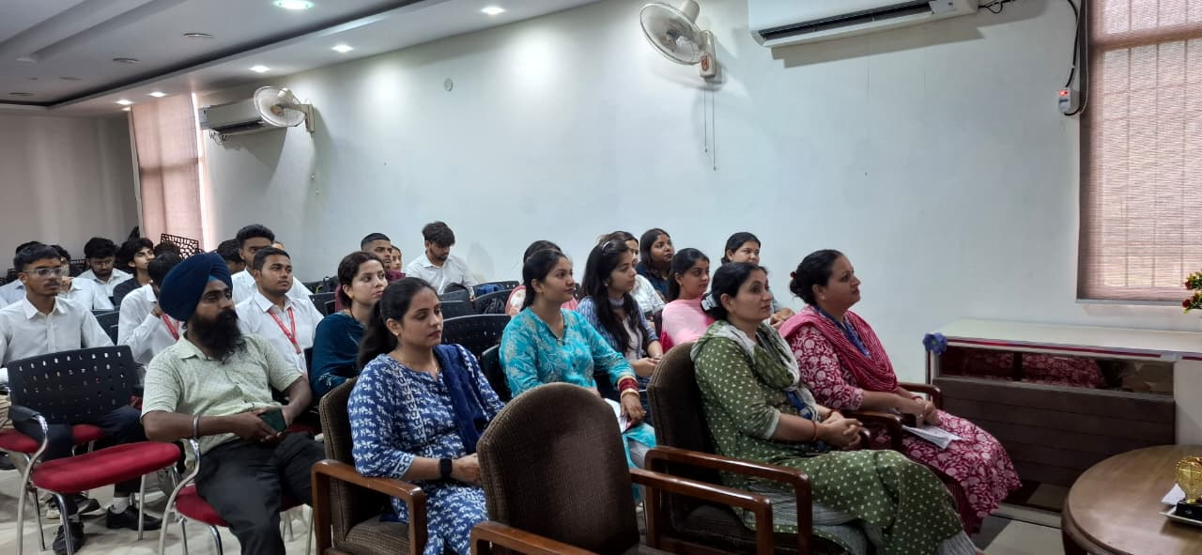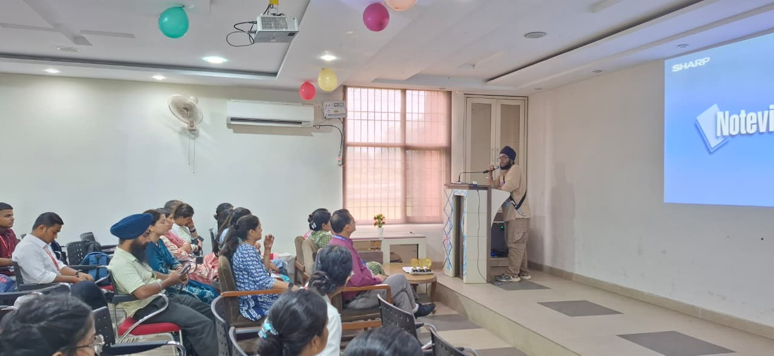

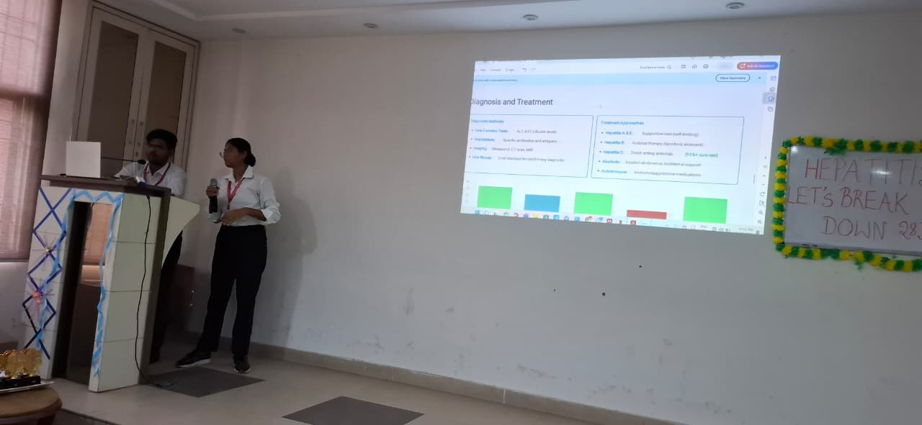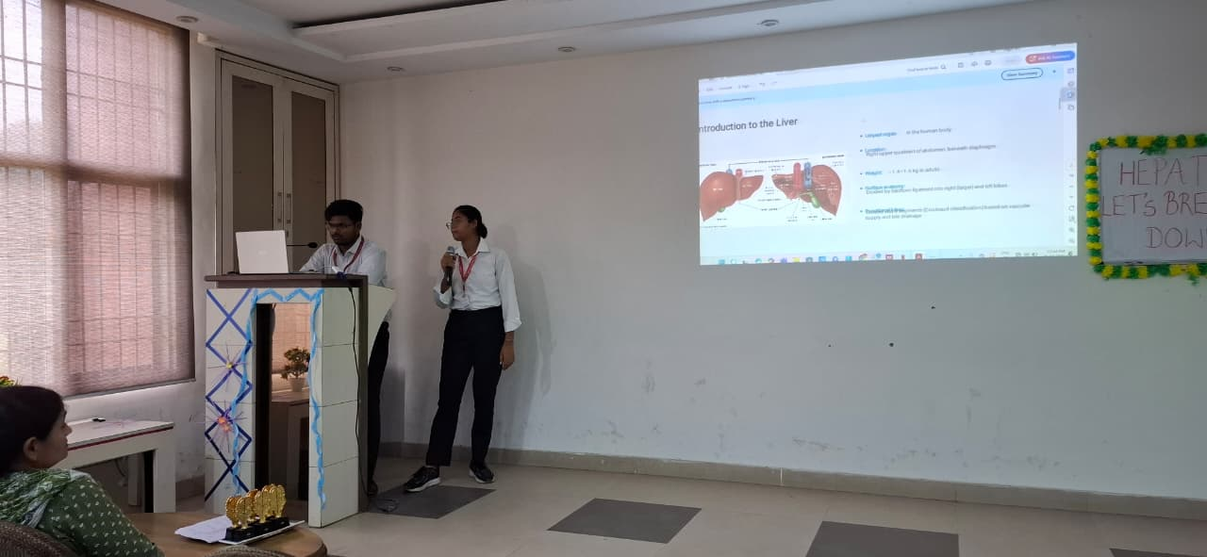

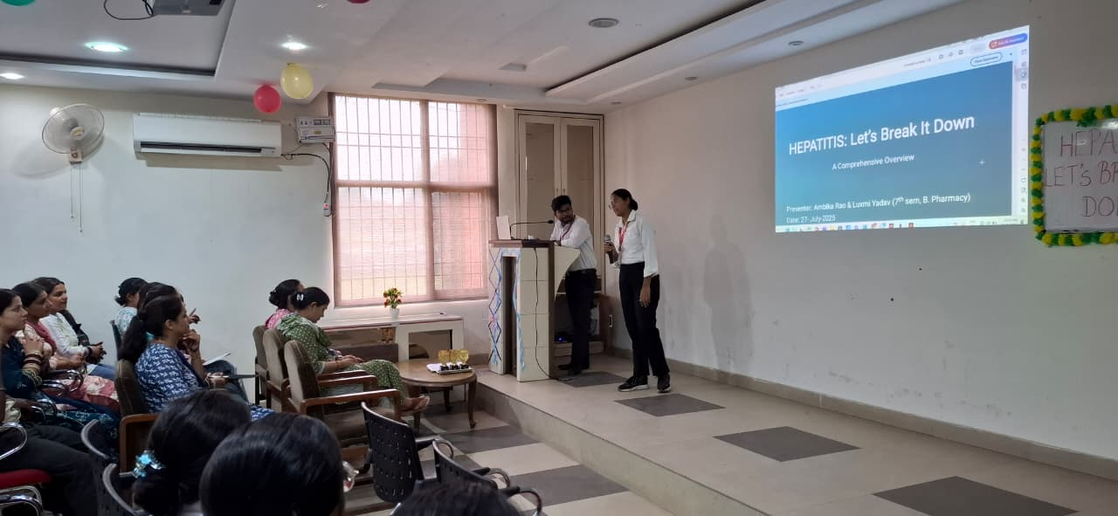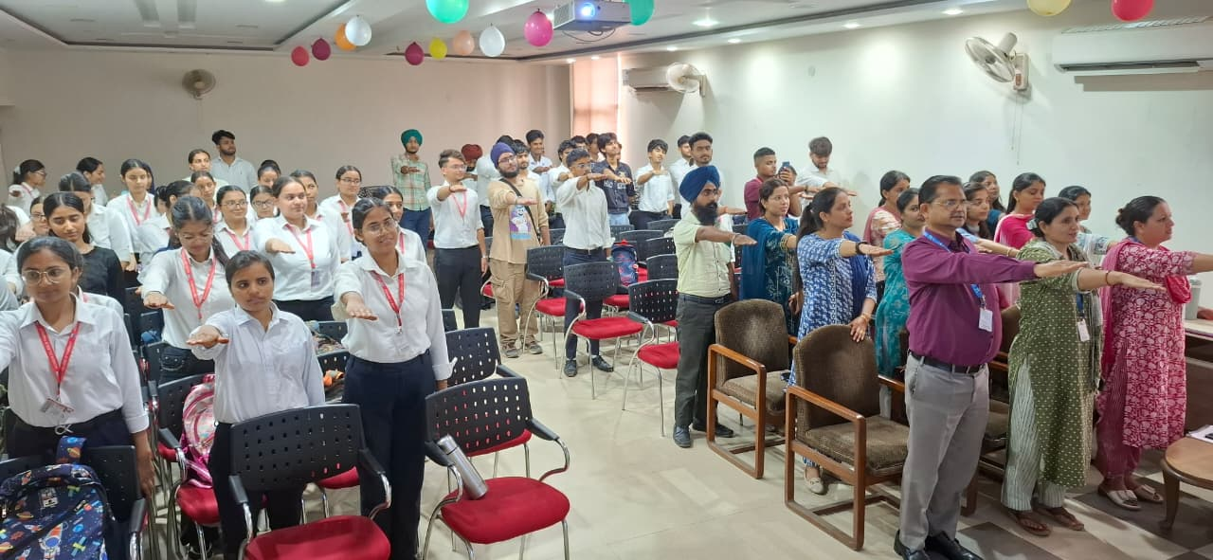

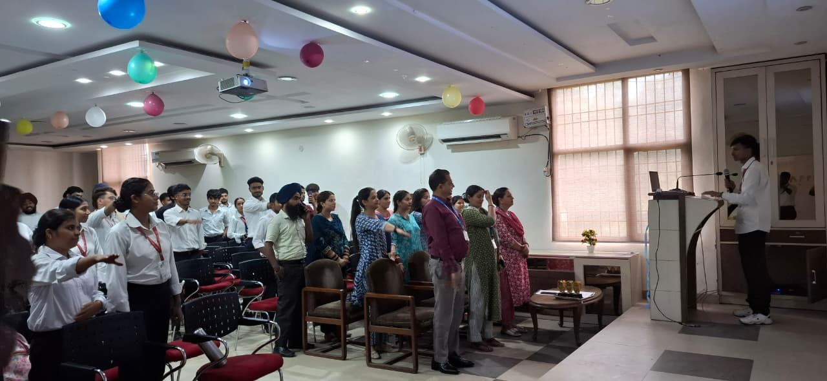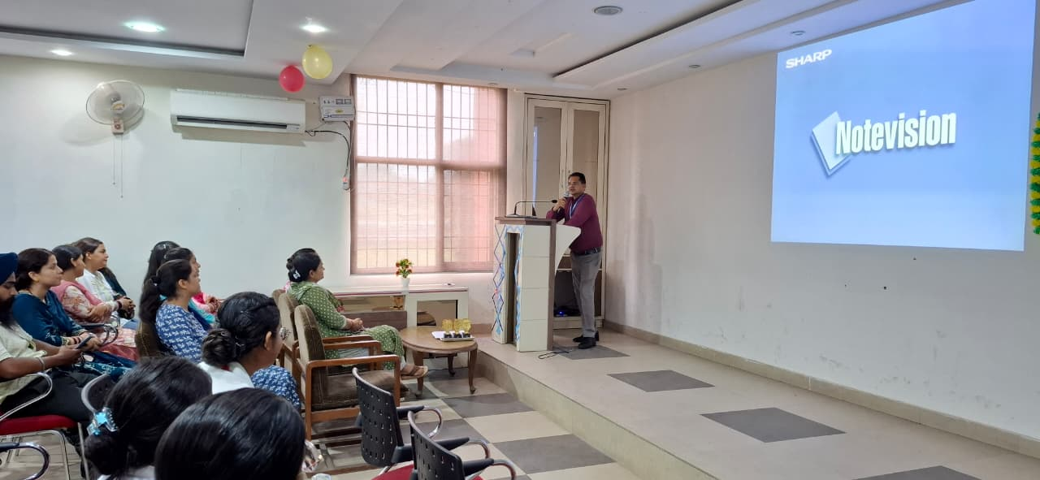
Students And Faculty Taking Plege

