Report on visit to Botanical Garden, Sarangpur& Elante Mall
(Chandigarh)

The Botanical Garden & Nature Park at Sarangpur is a large‐scale botanical facility established by the Chandigarh Administration with the purpose of plant conservation, environmental education, eco-tourism, and research. It spans about 176 acres and includes multiple specialized sections for medicinal plants, ornamental/flowering trees, aquatic species, rare plants, a Japanese Garden, tropical rainforest bulbous plants, etc. Sachdeva College of Pharmacy, Ghauran visited to Botanical Garden and Elante Mallon 1st of October 2025 where 50 of the B. Pharmacy and D. Pharmacy students along with 2 faculty members named Mrs. Rupinder Kaur and Mr. Gurinder Singhaccompanied.

Objectives of the Visit
- To observe and study diverse plant species (medicinal, ornamental, aquatic, rare) in their natural or semi‐natural habitats.
- To understand conservation efforts, ex-situ conservation, and how botanical gardens function as centres of research and education.
- To gain hands-on experience (identifying species, learning uses of medicinal plants, understanding ecological interaction.
- To promote bonding and informal learning outside the classroom environment.

Experience / Student Feedback
- Students found the hands-on aspect very engaging—seeing live plant species, being able to ask questions, relating medicinal plants to what they learn in theory
- The diversity impressed many — especially rare, aquatic, and bonsai sections
- Most enjoyed the greenery, fresh air, serenity, as a break from indoor/urban settings
- Some felt time was a bit short to cover all sections in detail
- Students expressed that the visit was both educational and enjoyable. It helped them connect theoretical knowledge with practical insights in a relaxed and engaging environment. They appreciated the efforts of the college and faculty in organizing such experiential learning opportunities

Conclusions:
The visit was successful in meeting its objectives: it enhanced student understanding of plant biodiversity, conservation practices, ecological principles, and the role of botanical gardens in environmental awareness. It also provided a good opportunity for experiential learning.During our visit, Mr. Sandeep Singh, Field Officer, had given every minute detail of the botanical garden.He also gave us gift hamper of FiveMedicinal Plants. The visit to Elante Mall proved to be a fruitful learning experience, combining education with recreation. It helped students understand the commercial aspects of retailing and business management. Such initiatives are highly recommended for enhancing students’ practical knowledge and soft skills.

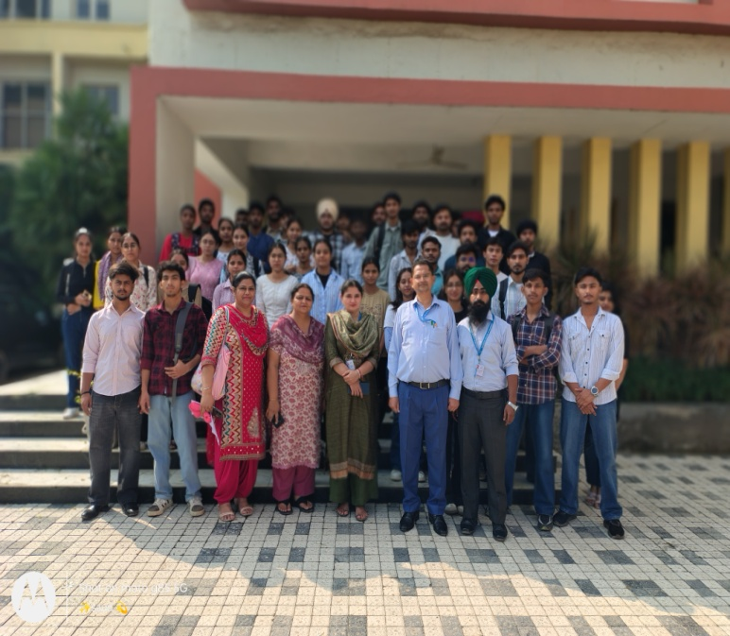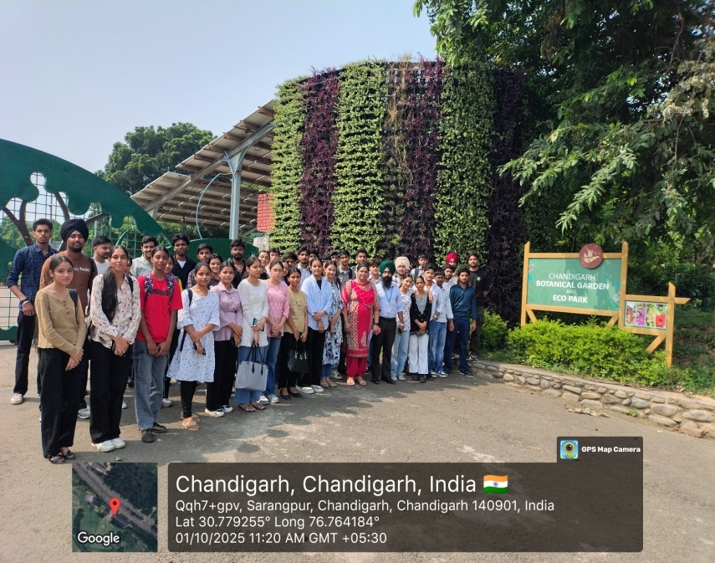
HODs and Principal along with Faculty and Students Entry Gate of Botanical Garden

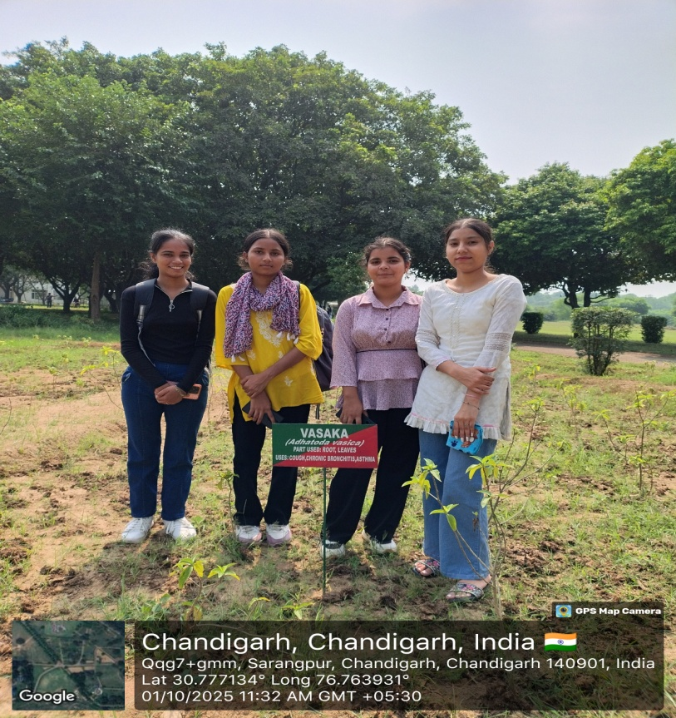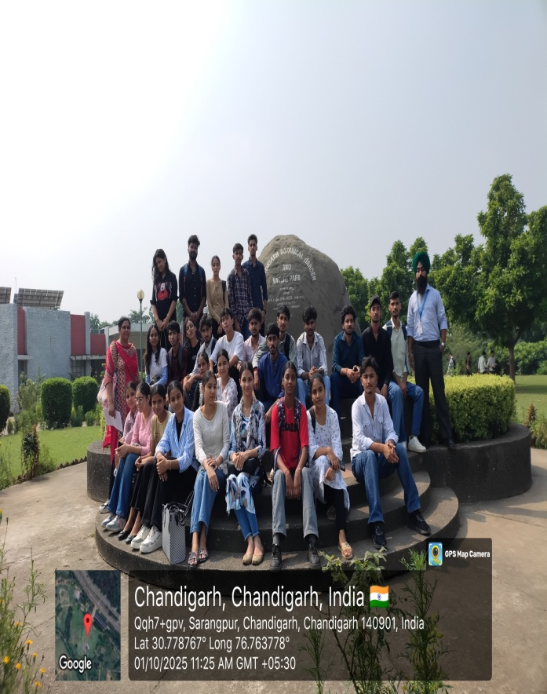
Plant visit in Botanical Garden Picturesque View of Botanical Garden

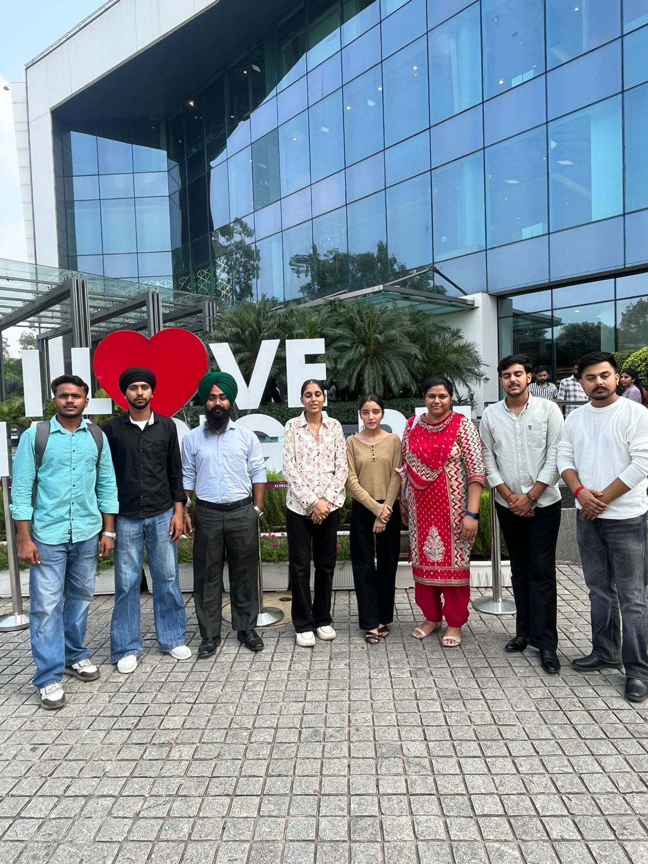
Visit to Elante Mall

