Sachdeva College of Pharmacy, Gharuan, Mohali
ANNUAL SPORTS MEET Date: 13 March 2026
The Annual Sports Meet was successfully organized at Sachdeva College of Pharmacy, Gharuan, Mohali, on 13th March 2026. The event witnessed enthusiastic participation from students of both B.Pharmacy and D.Pharmacy, along with the active involvement of faculty members.
All participants reported at 9:20 AM, demonstrating punctuality and discipline. The event began with a March Past, followed by the National Anthem, expressing unity and respect for the nation.
Various indoor and outdoor games were conducted, including races, football, kho-kho, volleyball, kabaddi, tug of war, shot put, dodgeball, chess, carrom, badminton, and arm wrestling. Proper arrangements for first aid and refreshments were made.

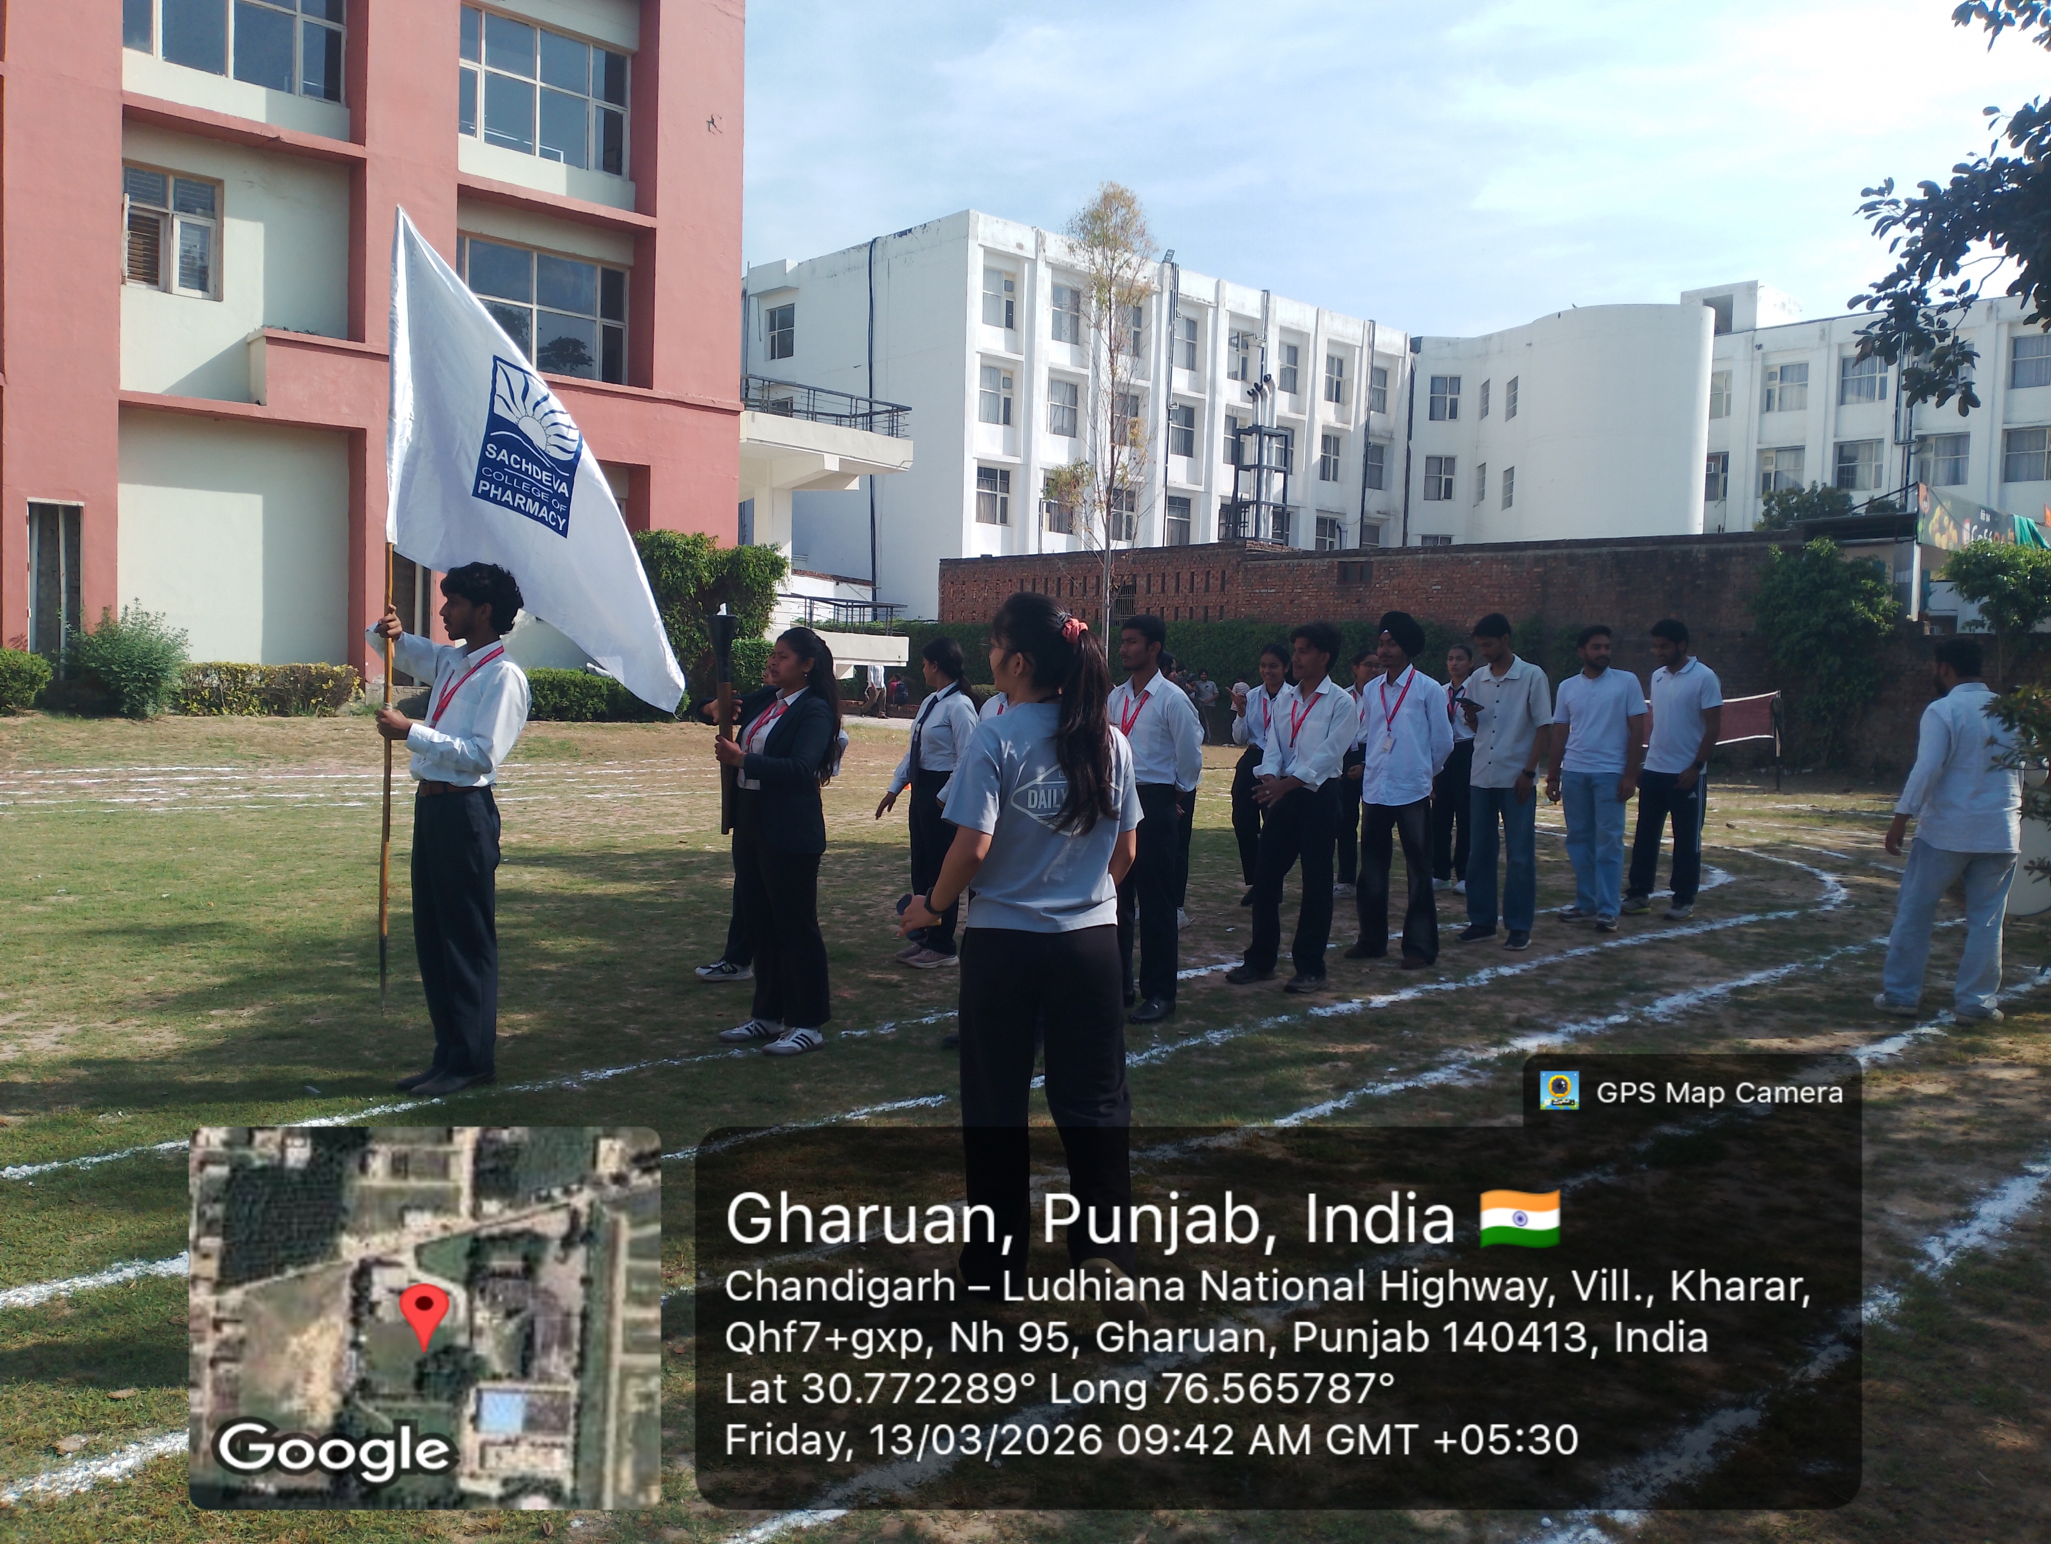
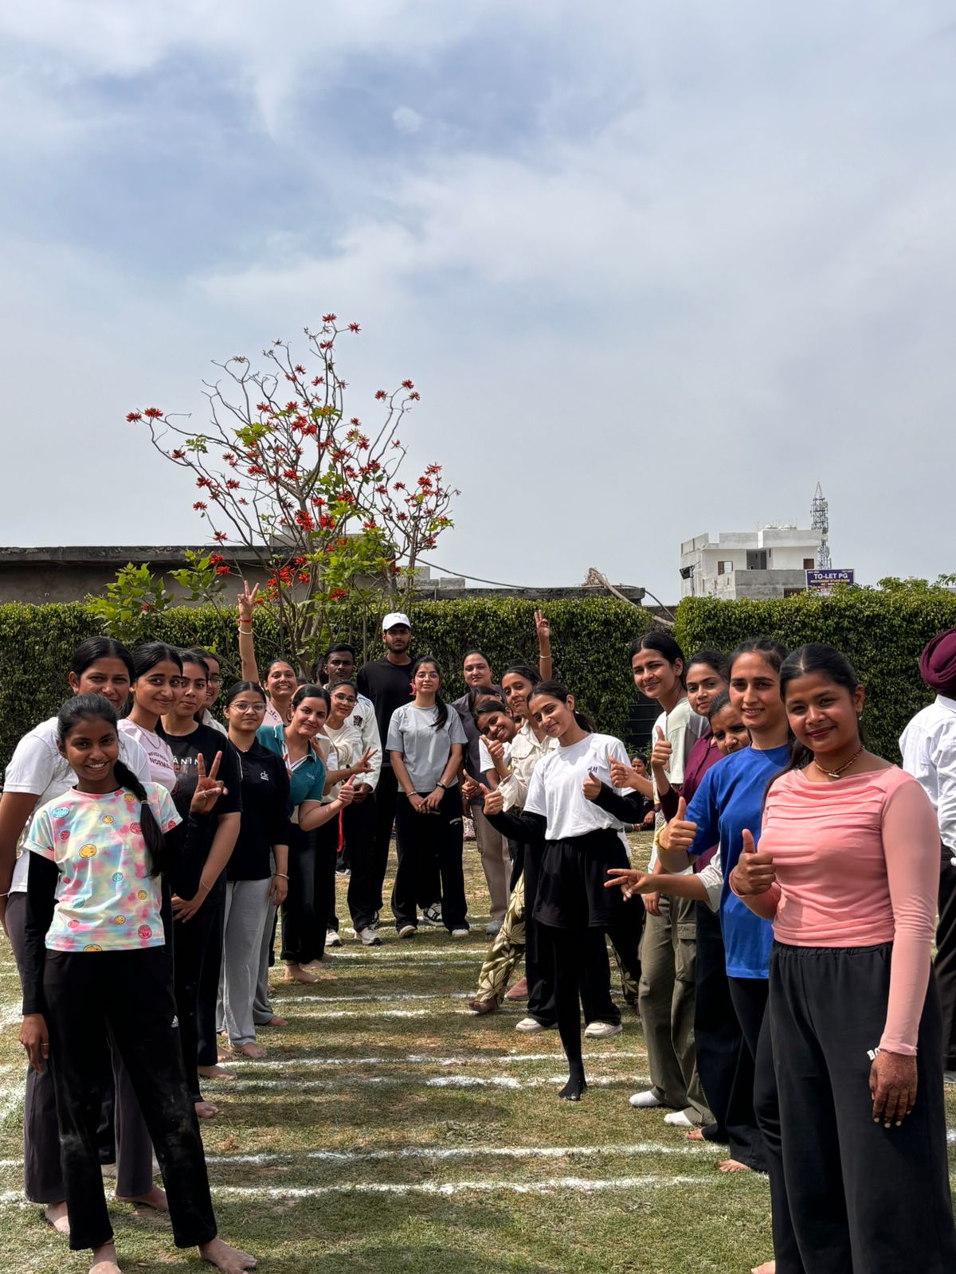

RESULTS
Track Events
Relay Race (Girls): 1st Ankita, Meenakshi, Diya, Geetanjali 2nd Anjali Negi, Annu, Neha, Payal
100m (Girls): 1st – Nimrit , 2nd – Anu, 3rd – Geetanjali
200m (Girls): 1st – Nimrit | 2nd – Soni | 3rd – Neha
100m (Boys): 1st – Akash | 2nd – Arnav
200m (Boys): 1st – Akash | 2nd – Navish | 3rd – Amritpal
Relay (Boys): 1st – Sidharth, Amritpal, Navish, Aryan | 2nd – Afzal, Praduman, Arnav, Rohit
Other Events
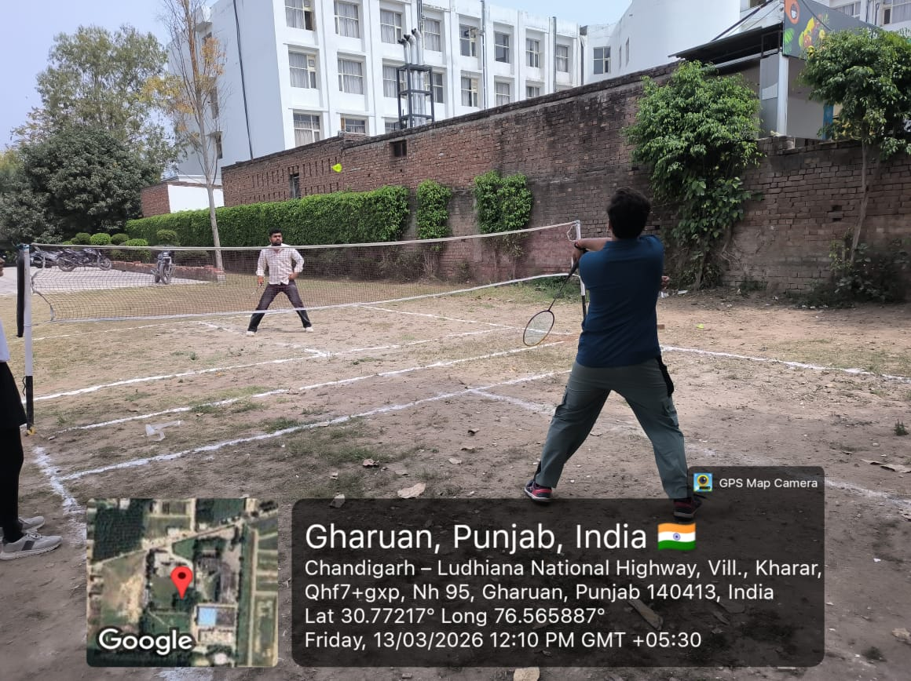
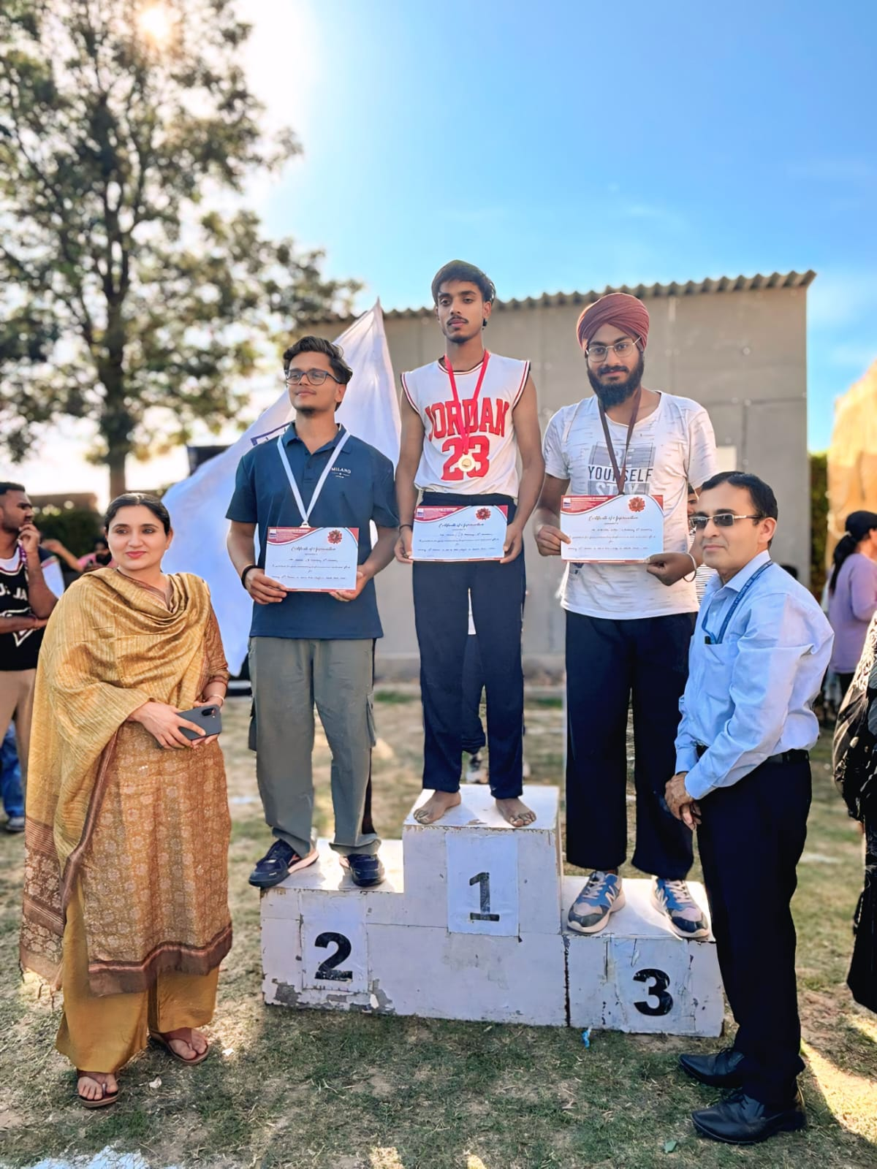
Three-Leg (Girls): 1st – Annu, Neha | 2nd – Meenakshi, Geetanjali
Three-Leg (Boys): 1st – Aryan, Navish
Push-Ups: 1st – Shivam | 2nd – Aryan | 3rd – Akash, Sidharth
Arm Wrestling (Boys): 1st – Yuvraj | 2nd – Sidharth | 3rd – Rohit
Arm Wrestling (Girls): 1st – Arti, Meenakshi | 2nd – Anjali

Prize distribution Badminton

Indoor Games

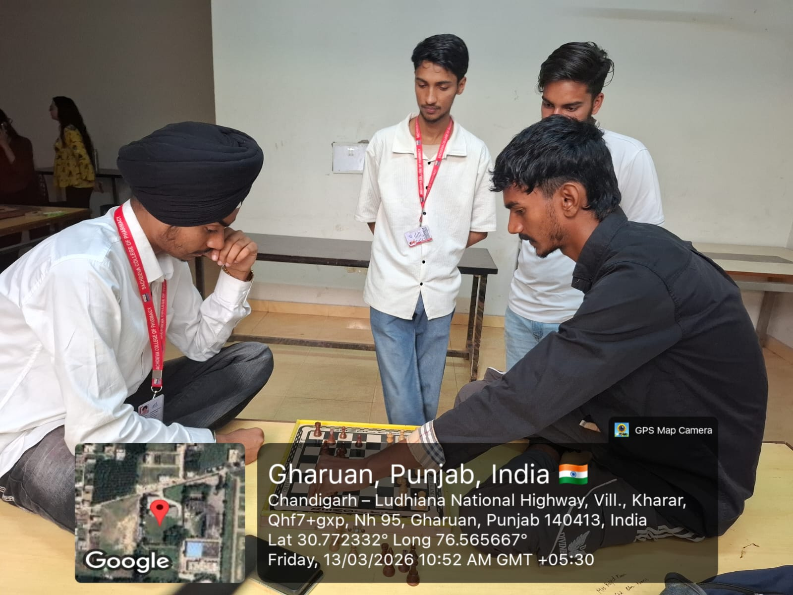
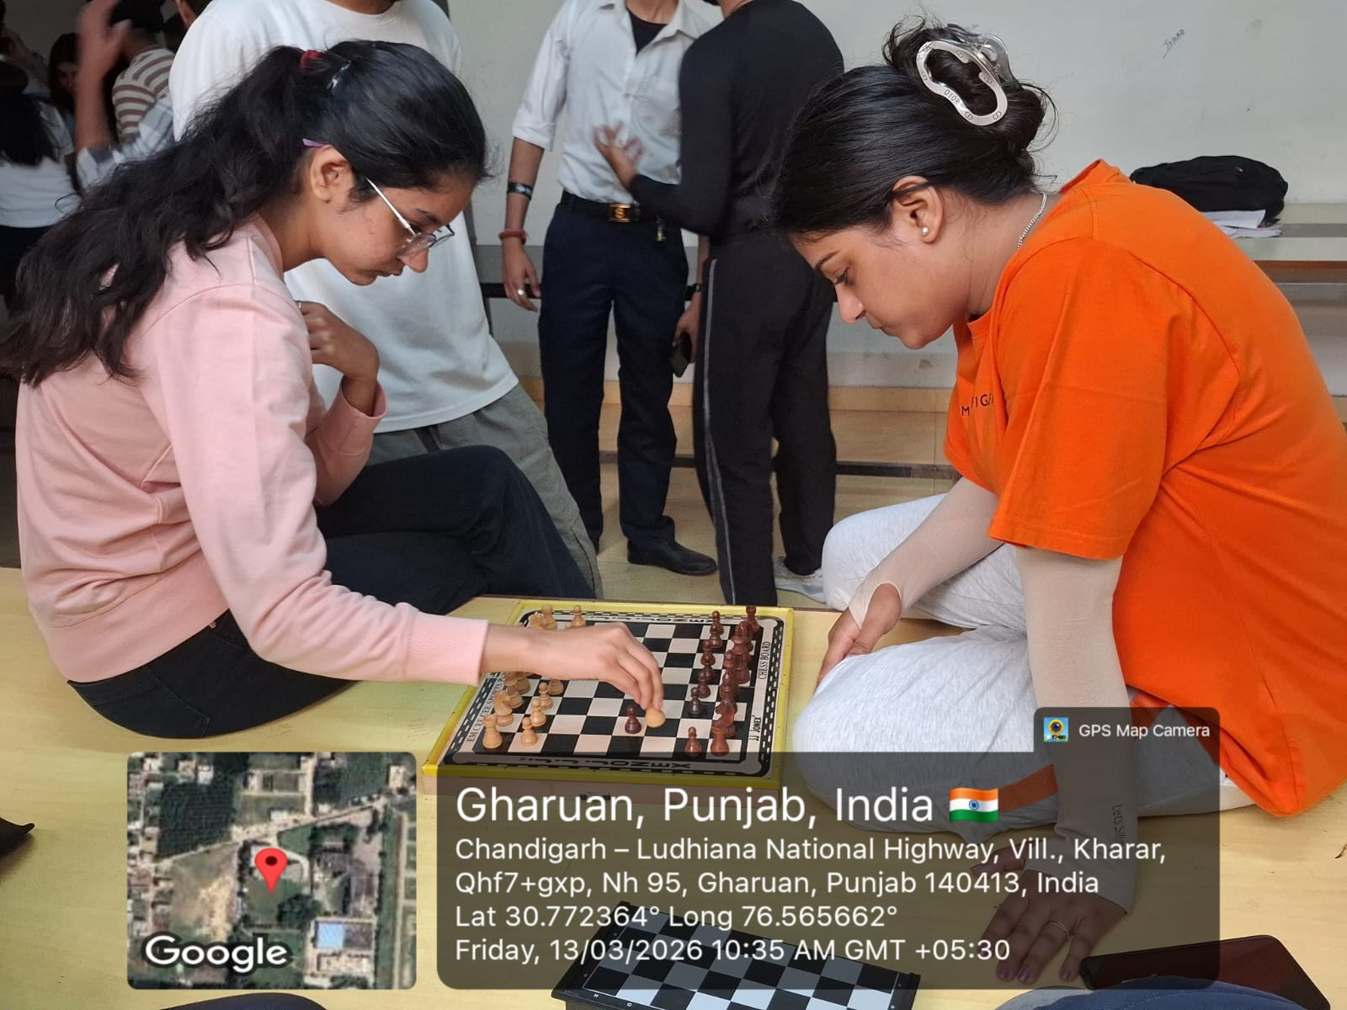

Chess (Boys) Chess (Girls)
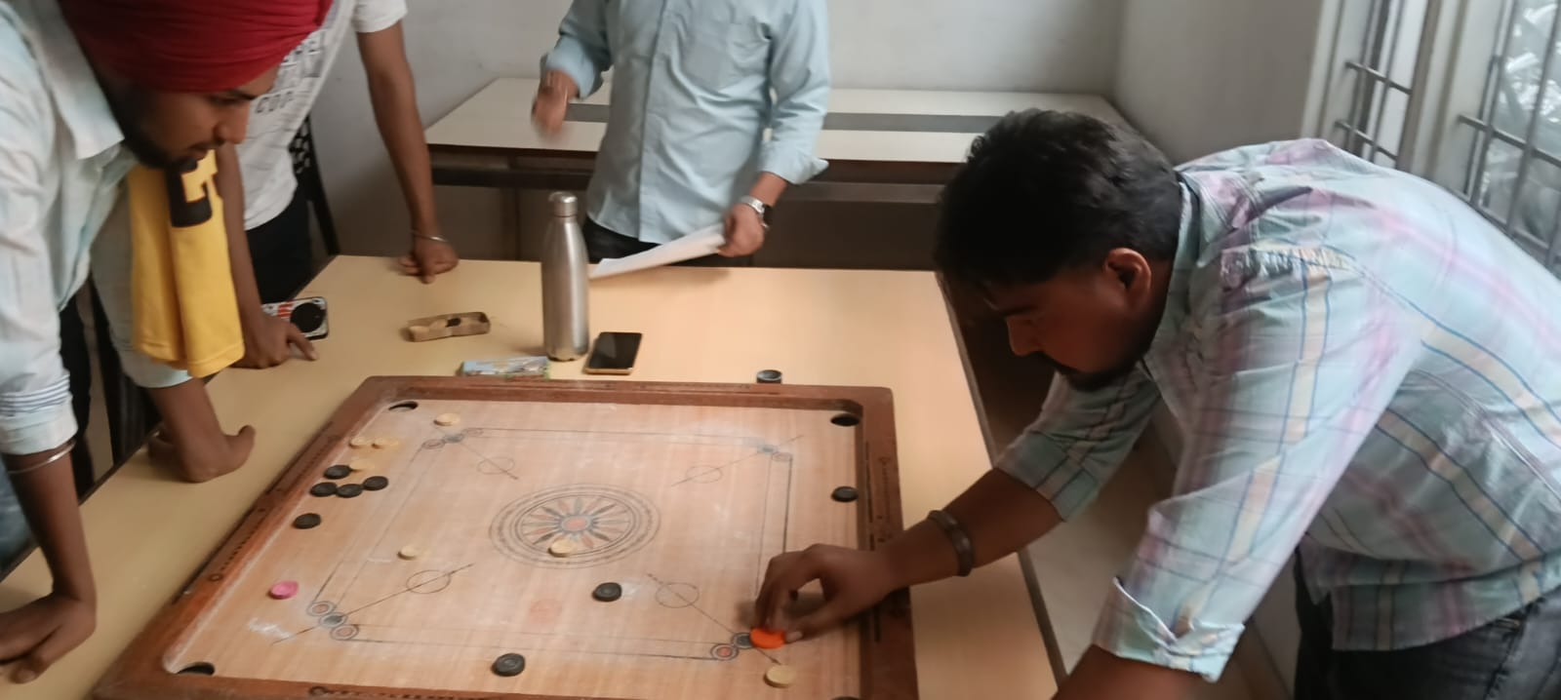

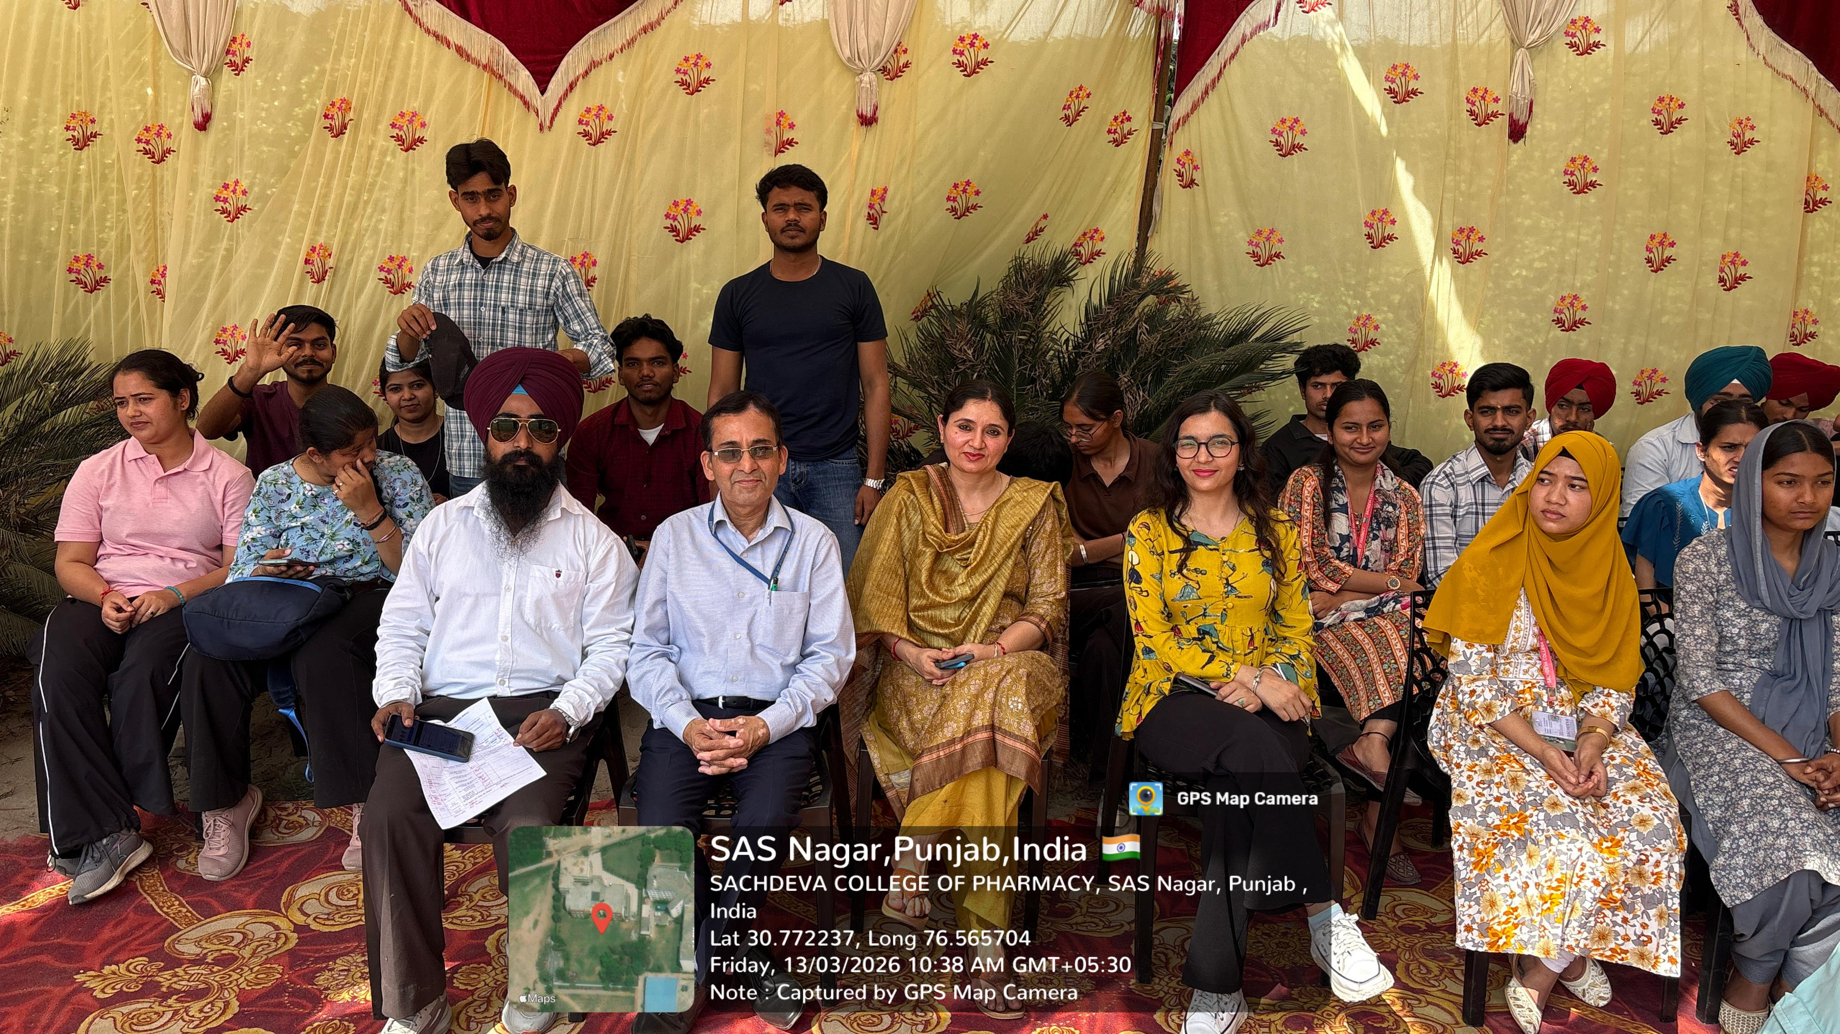

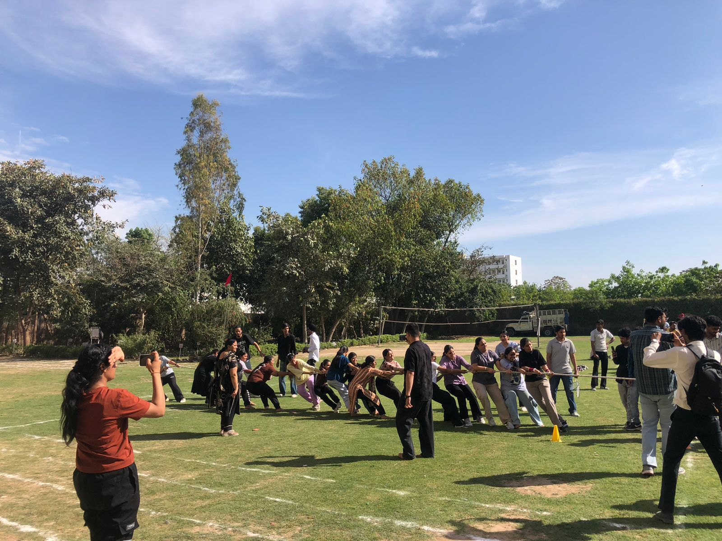

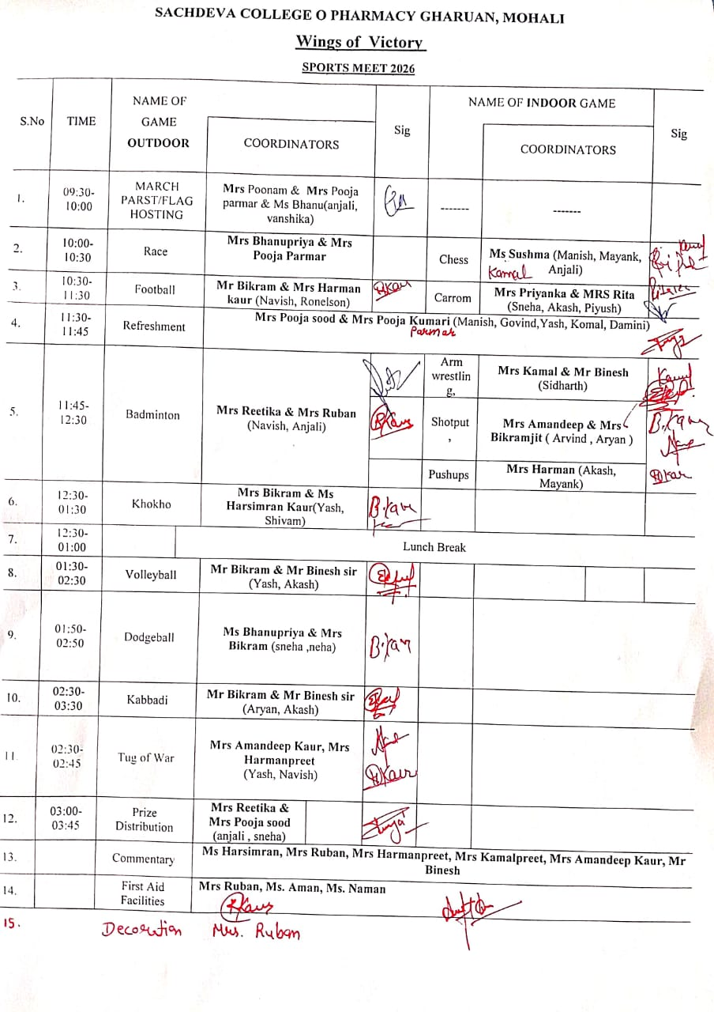
Duty Chart
Sports Event Participants List
3 Leg Race
Year | Participants
1st Year | Priya, Nimrit, Soni, Sarabjeet
4th Year Boys | Navish, Aryan
4th Year Girls | Geetanjali, Sneha, Divya, Neha, Ankita, Mouli
100m Race
Year | Category | Participants
1st Year | Boys | Praduman, Vikranth, Ronelson, Niku, Anish, Aditya Pal, Arnav
1st Year | Girls | Nimrit, Priya, Vandita, Pawan Deep Kaur
2nd Year | - | Neha, Anu
3rd Year | Boy | Akash
3rd Year | Girl | Komal
4th Year | Boy | Navish
4th Year | Girls | Divya, Neha, Mouli, Ankita
200m Race
Year | Category | Participants
1st Year | - | Amanjot, Soni, Palak, Bhumika
3rd Year | Boy | Akash
3rd Year | Girl | Komal
4th Year | Boy | Navish
4th Year | Girls | Mouli, Ankita, Divya, Neha
Badminton
Year | Participants
1st Year | Jasnoor, Nimrit, Vandita, Priya, Ravinder, Roshan, Pradyumn
2nd Year | Annu, Payal, Anjali Negi, Manish, Balkar, Harman, Sooraj, Kishan
3rd Year | Yuvraj, Imran, Nikhil, Harman, Manir
4th Year | Meenakshi, Mouli, Neha, Reshama, Geetanjli, Navish
Kho-Kho
Year | Participants
1st Year | Sarabjit, Pawan, Vandita, Nimrit, Priya, Anjali, Amanjot, Bhumika, Soni, Palak, Harjashan, Simran
2nd Year | Shabnam, Sharan, Jaspreet, Anu, Darsh, Anjali Negi, Sachnoor, Harman, Payal, Navjot, Neha, Sneha
4th Year | Neha, Divya, Ankita, Mouli, Minakshi, Sneha, Rounak, Rozy, Mukesh, Laxmi, Reshma, Geetanjali

Open Ground Pictures
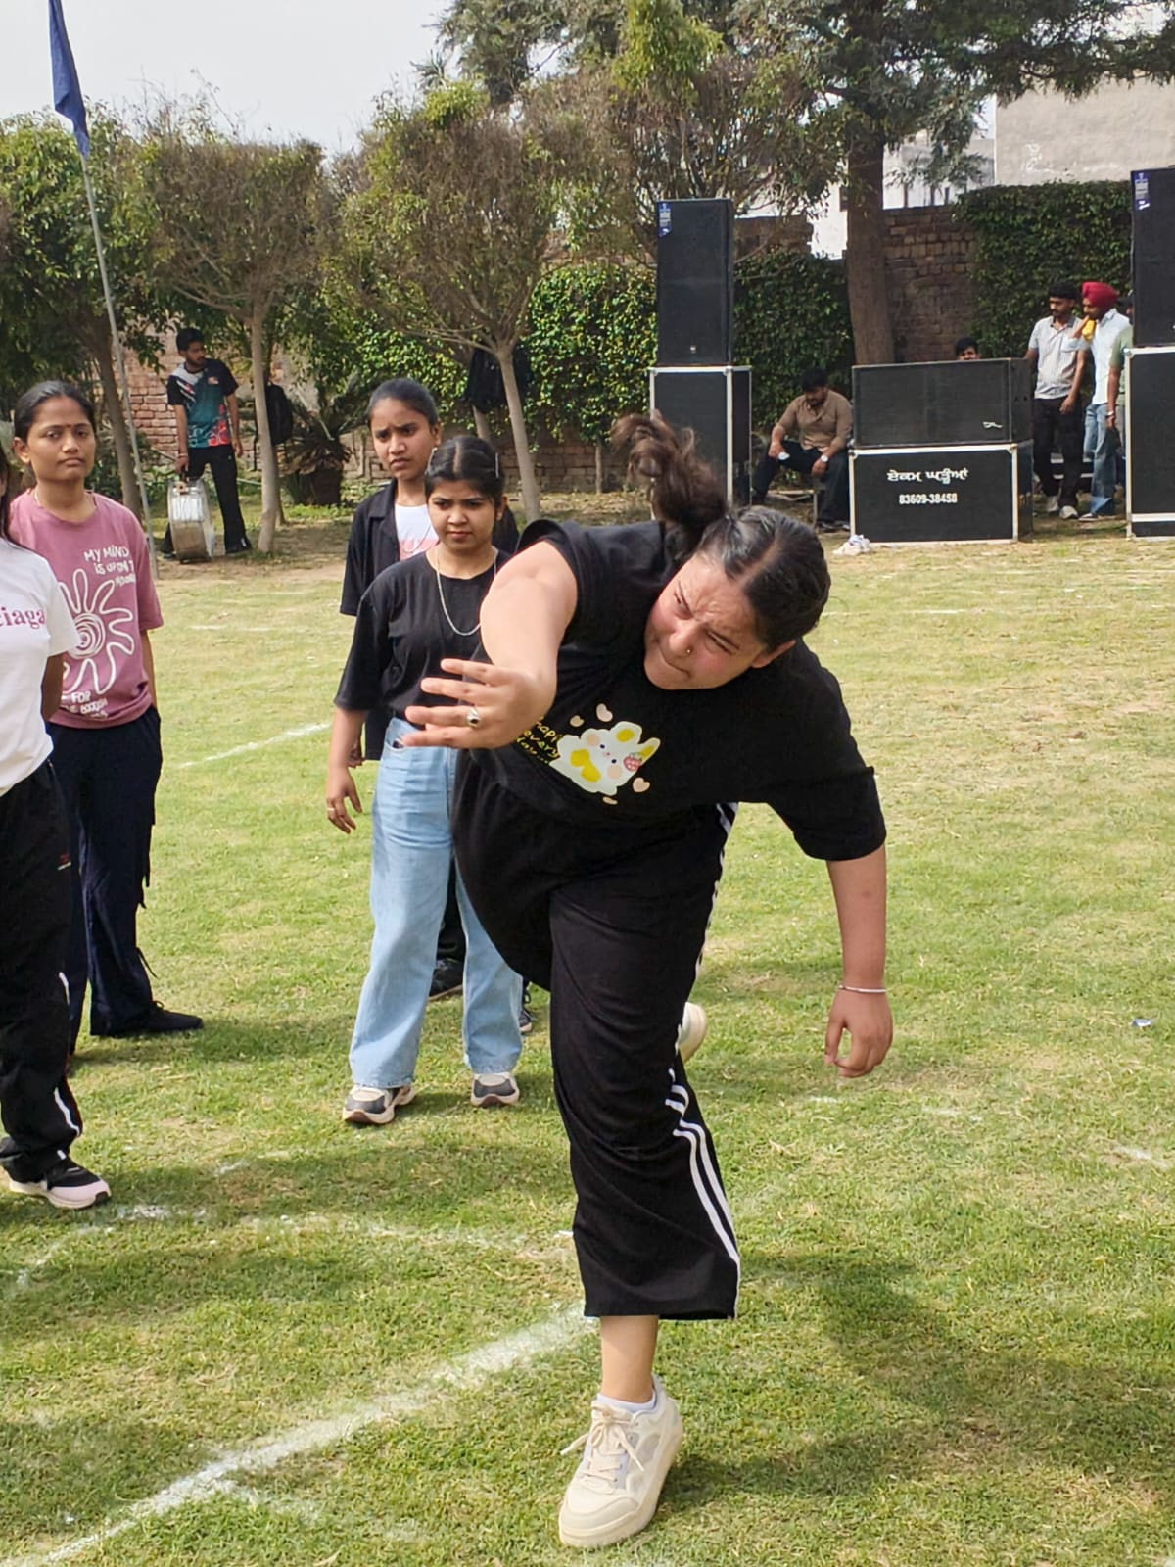
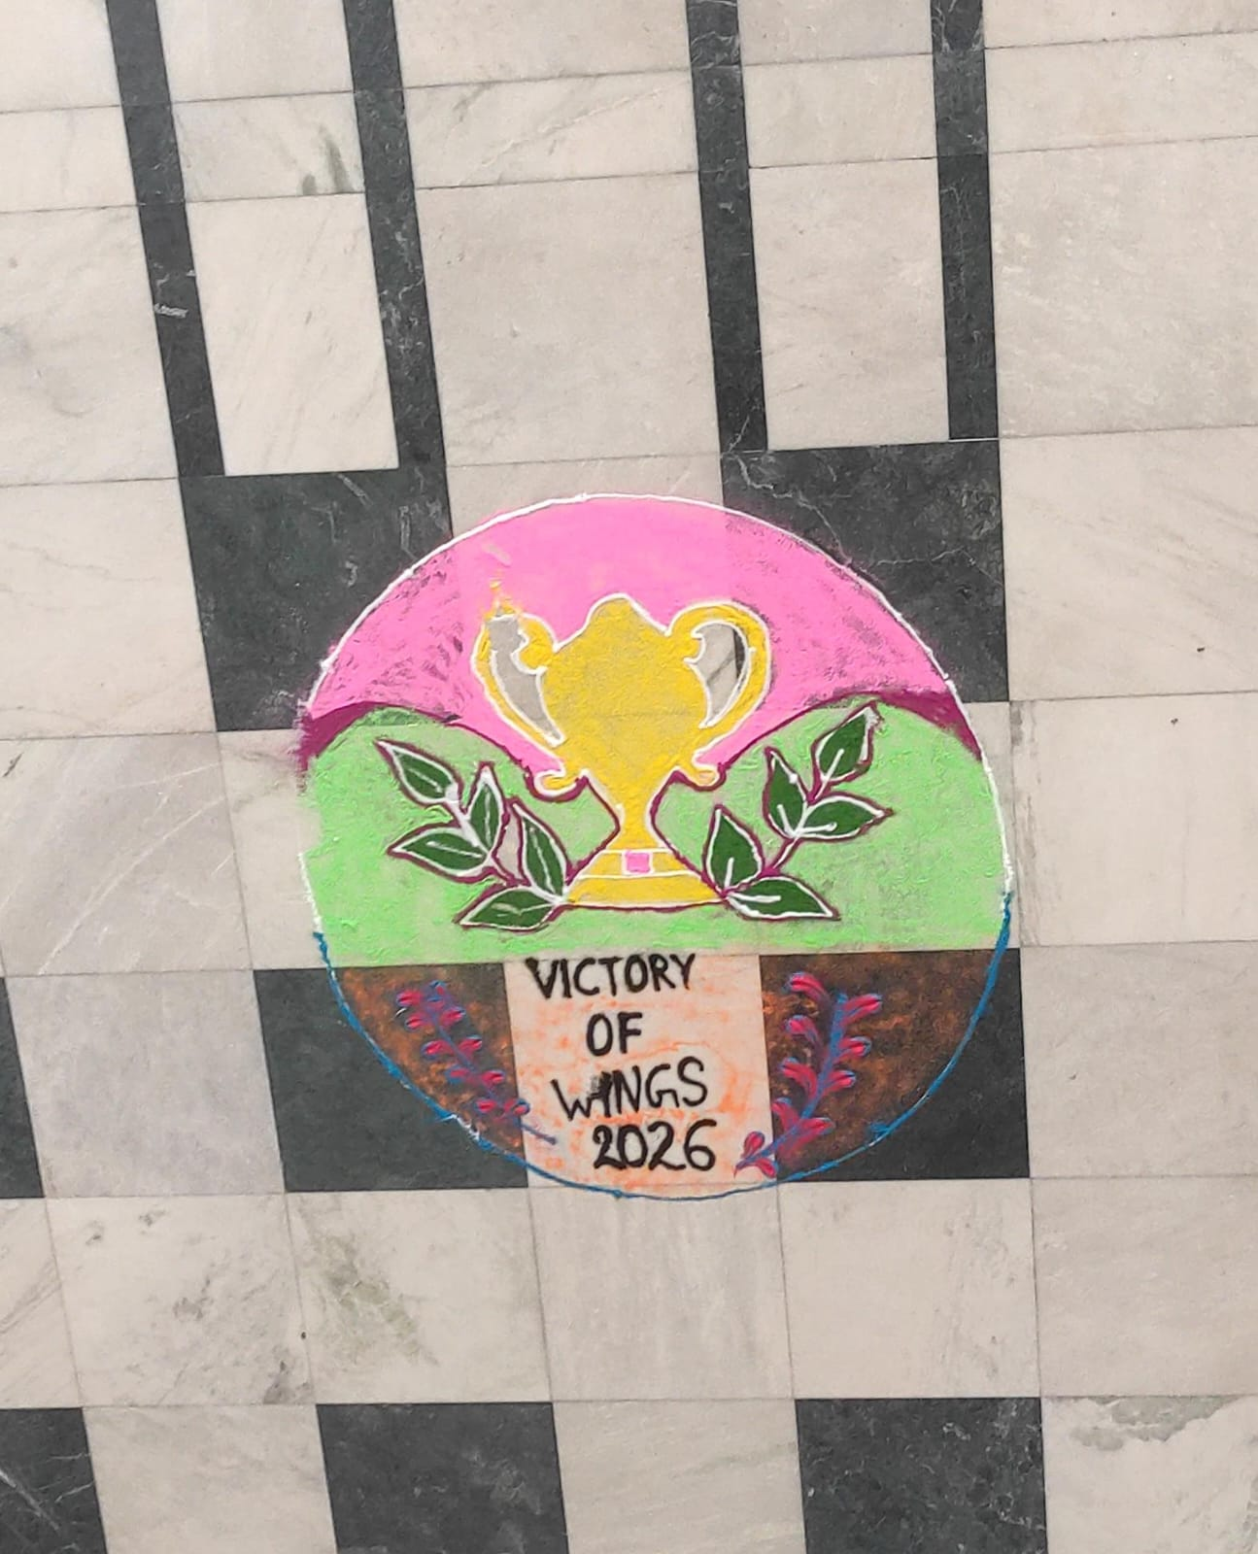
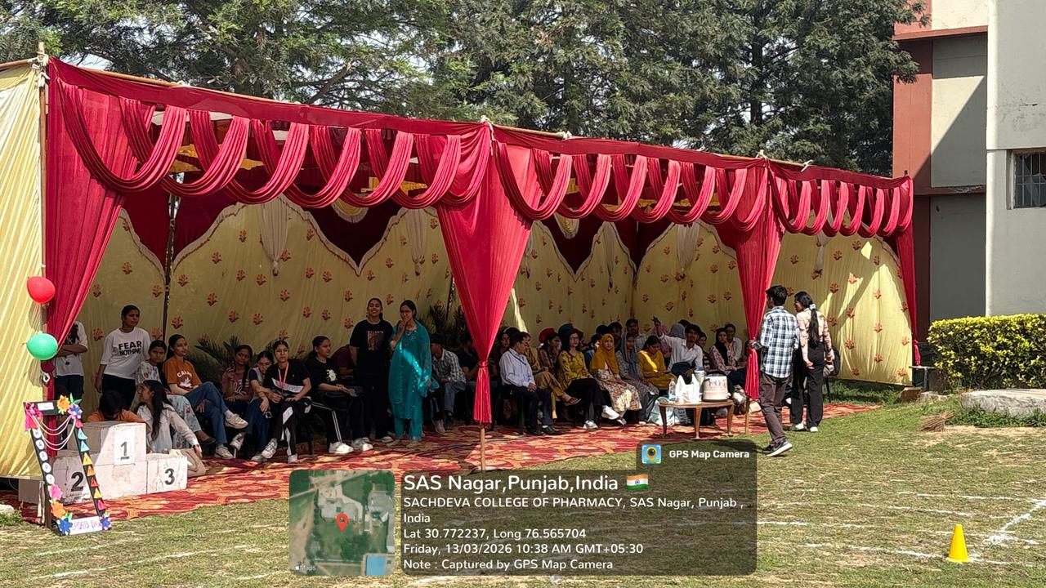
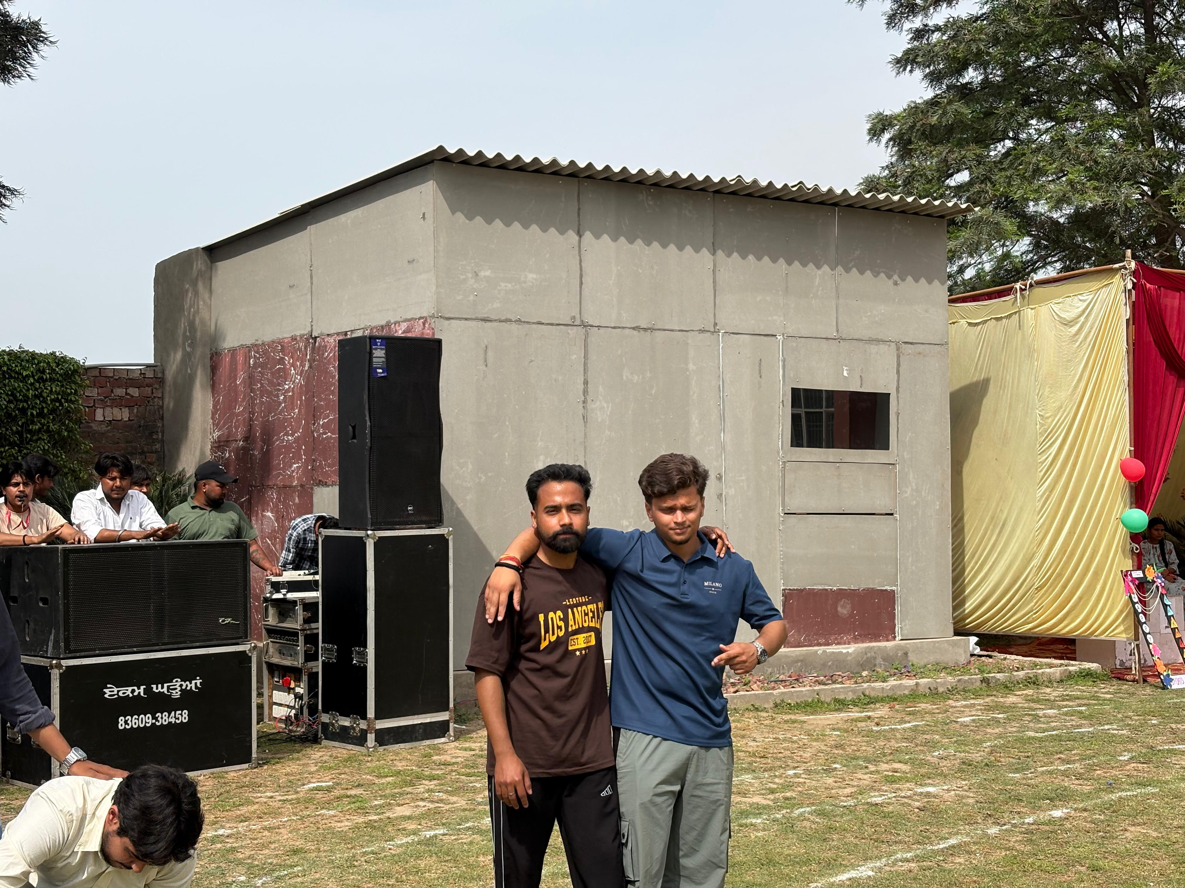
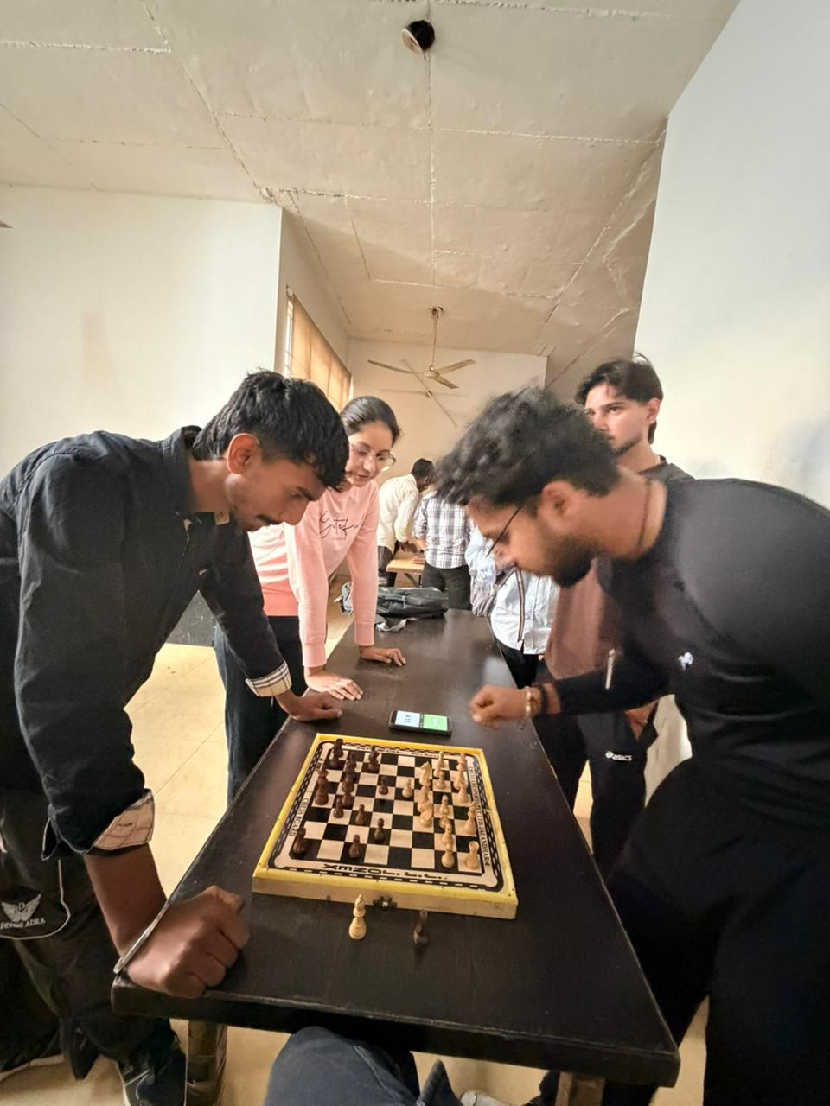
Chess (Boys): 1st – Kishan | 2nd – Ibrahim | 3rd – Afzal
Chess (Girls): 1st – Kavita | 2nd – Vandita
Carrom (Boys): 1st – Ibrahim | 2nd – Ravi Kant | 3rd – Kishan
Field Events:
Shot Put (Girls): 1st – Sneha | 2nd – Resham | 3rd – Neha
Shot Put (Boys): 1st – Arnav | 2nd – Arjun | 3rd – Yuvraj
Team Events

Badminton (Girls): 1st – Meenakshi, Neha
Badminton (Boys): 1st – Navish | 2nd – Nikhil | 3rd – Praduman
Kho-Kho (Girls Team): Anjali Negi, Sachnoor, Harman, Sneha, Navjot Kaur, Payal, Anshika, Sharanpreet, Annu, Darshpreet, Neha, Shabnam
Football (Boys Team): Navish, Ronelsom, Sidharth, Niku, Akhil, Sukhdev, Praduman
Volleyball (Boys Team): Rajit, Satnam, Harmandeep Singh, Balkar, Akhil, Gurpinder
Dodgeball (Girls Team): Divya, Meenakshi, Neha, Ankita, Geetanjali, Sneha
Tug of War (Girls Team): Arti, Navleen, Deepika, Muskan, Sneha, Anjali, Shivangi, Ramita, Vanshika, Resham
Prize Distribution
First position holders received trophies and gold medals, second received silver medals and third received bronze medals.
Conclusion
The event concluded successfully under the guidance of Principal Prof. S.P. Goel, Dr. Vandana Kharb HOD (B.Pharmacy) and Dr. Shilpi Sachdeva HOD (D.Pharmacy).

Sports Coordinator Hod’s(Signature) Principal(Signature)

